**Minimum Spanning Tree**

1. 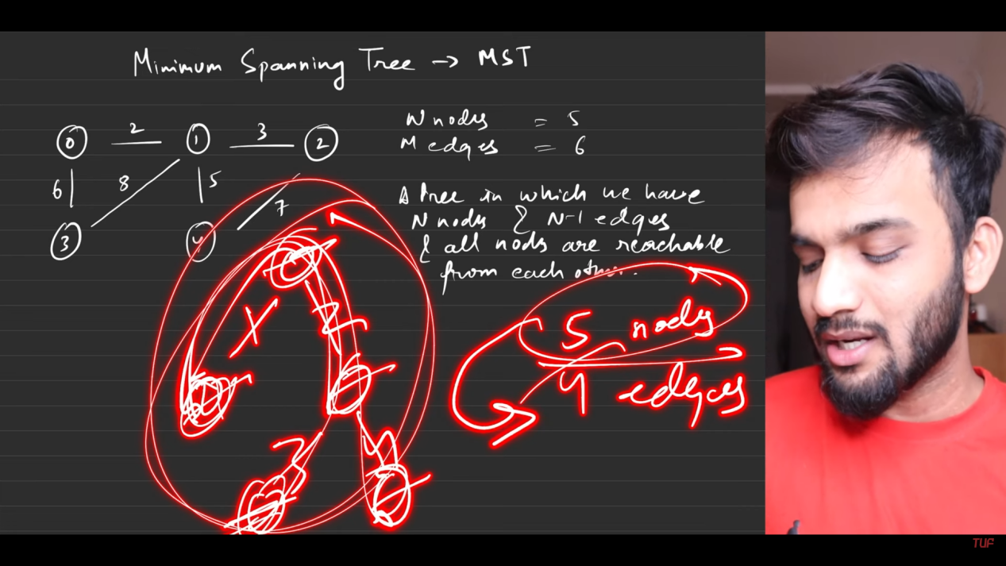
2. 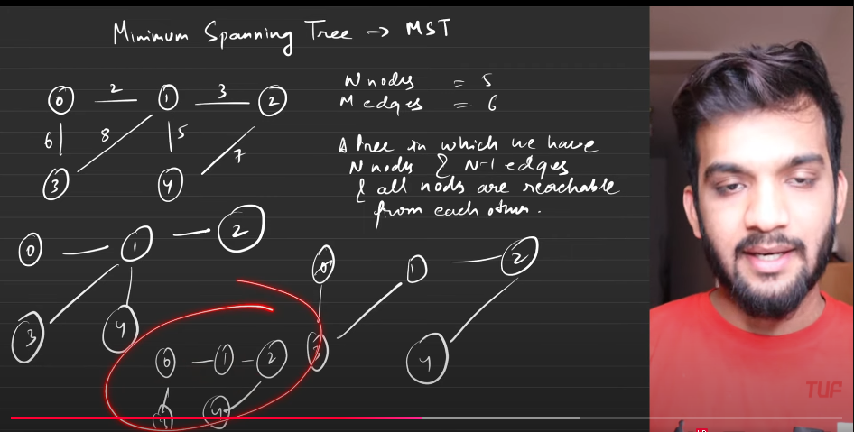
3. 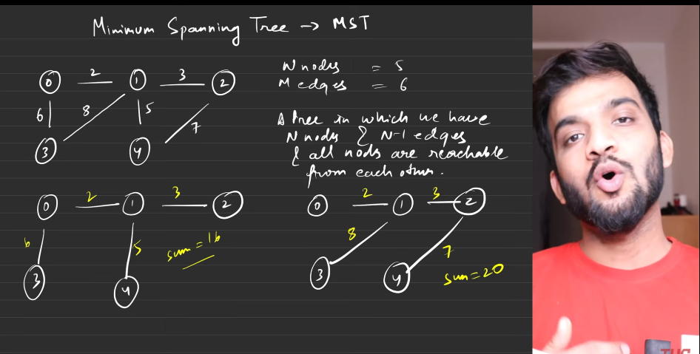
4. 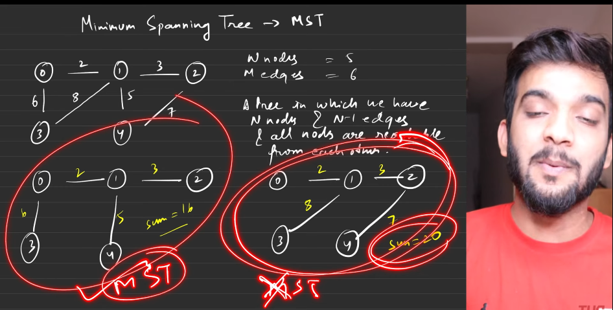
5. 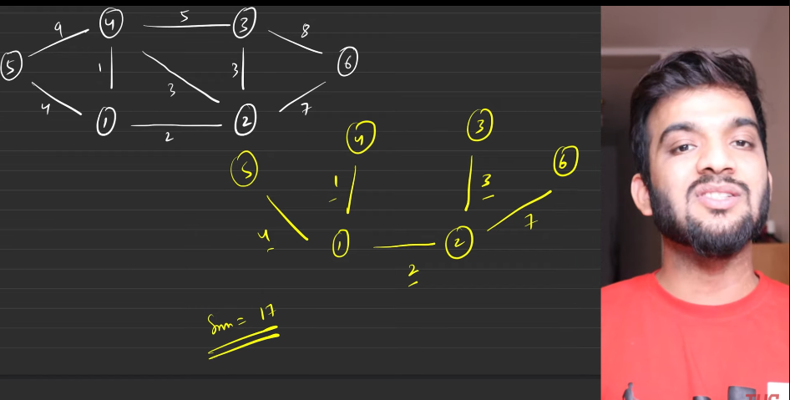
6. 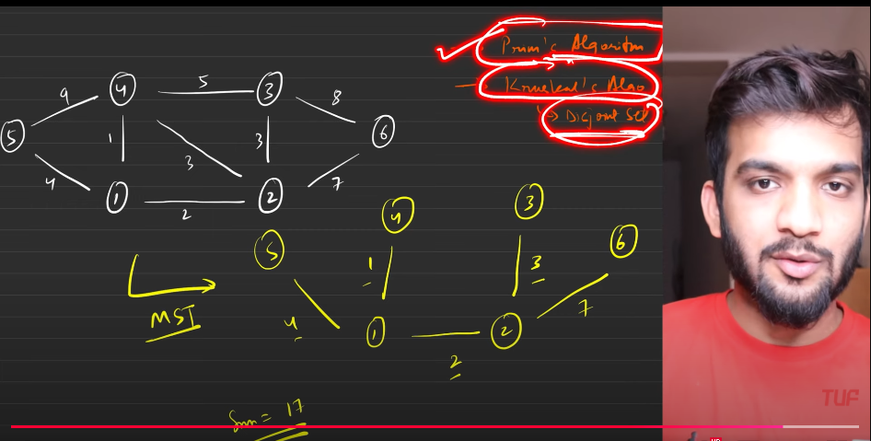

**Prims algorithm**

1. 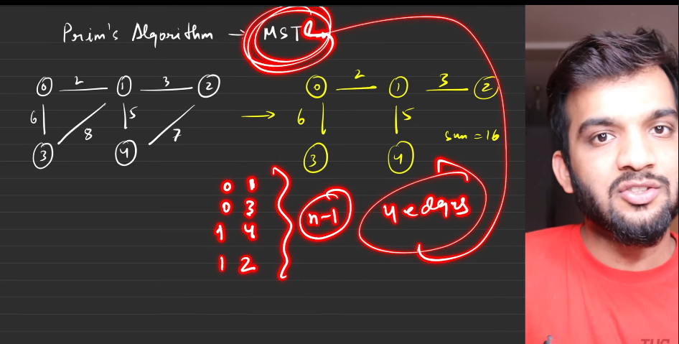
2. 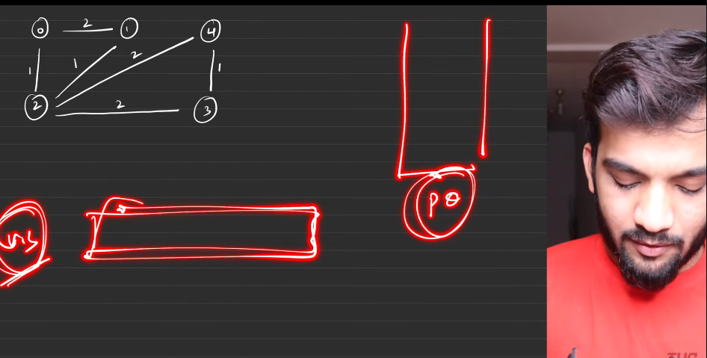

This is the initial configuaration.

1. 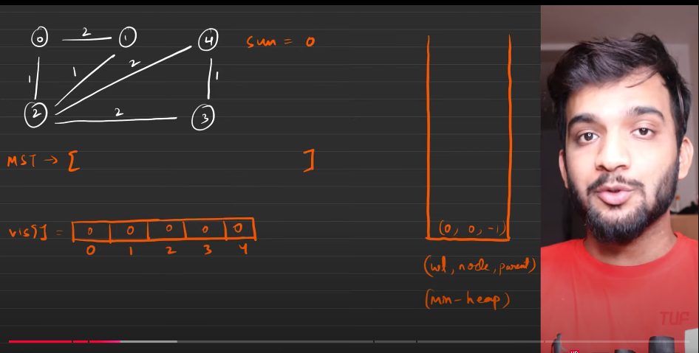
2. 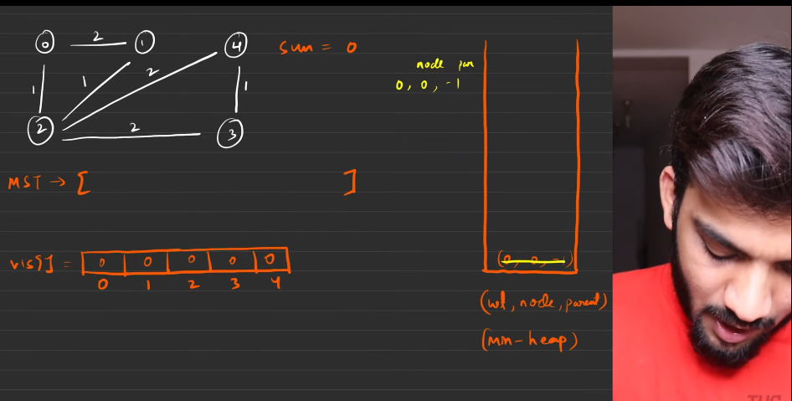
3. Do not add the source into MST.
4. 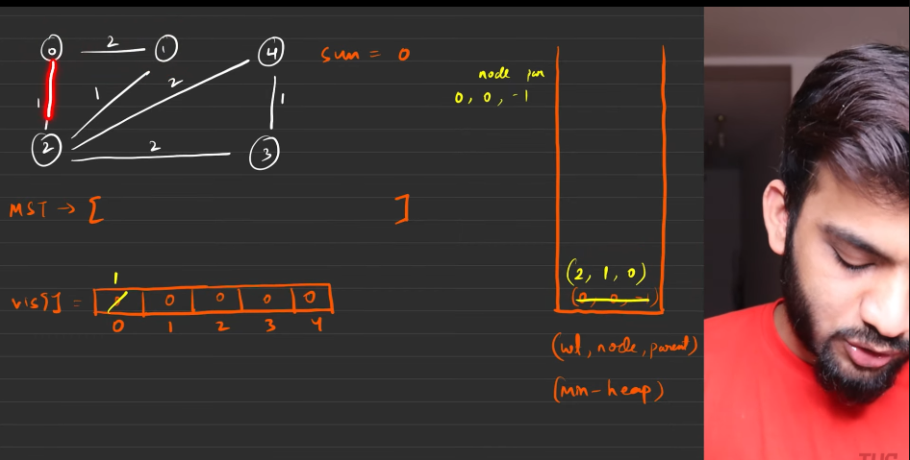
5. 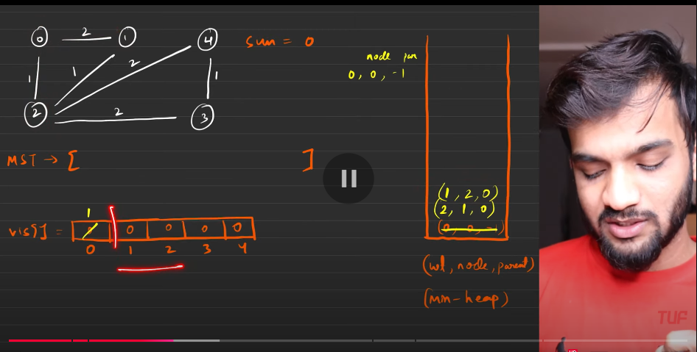
6. Now, do not mark them as visted. First the tarvesring shall happen first then we shall focus on the marking the node as visited or not. After popping the node from the min heap, then mark it as visited by taking all the necessary information. That is the next step .
7. 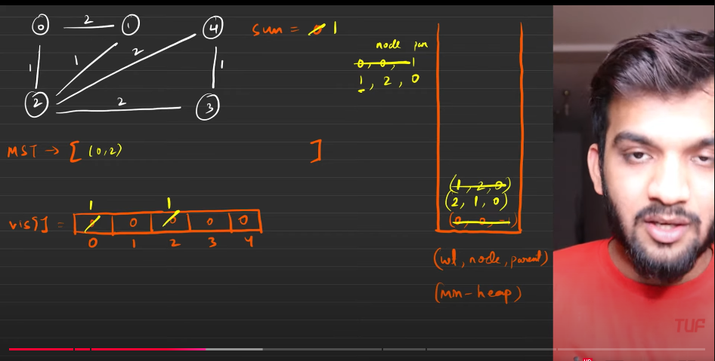
8. 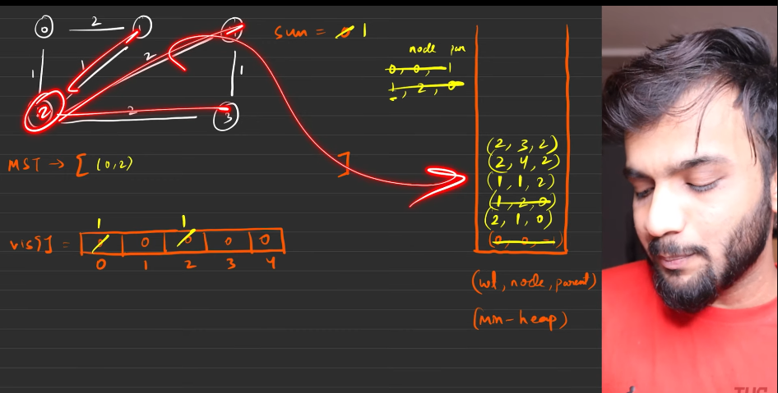
9. 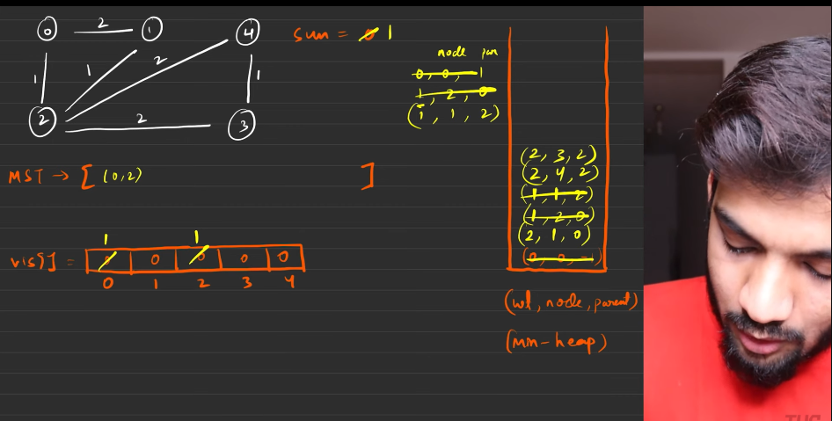
10. 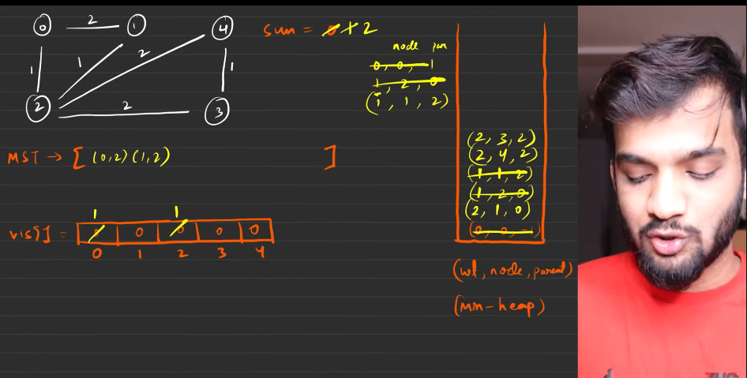
11. 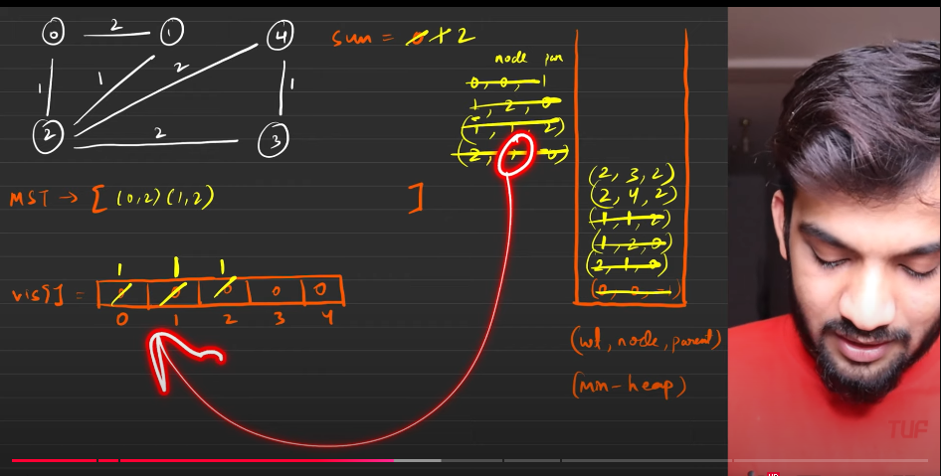
12. The entry on the minhea, has already been visietd , so you should not manke any altercations with the viited node and as well as the stack .
13. 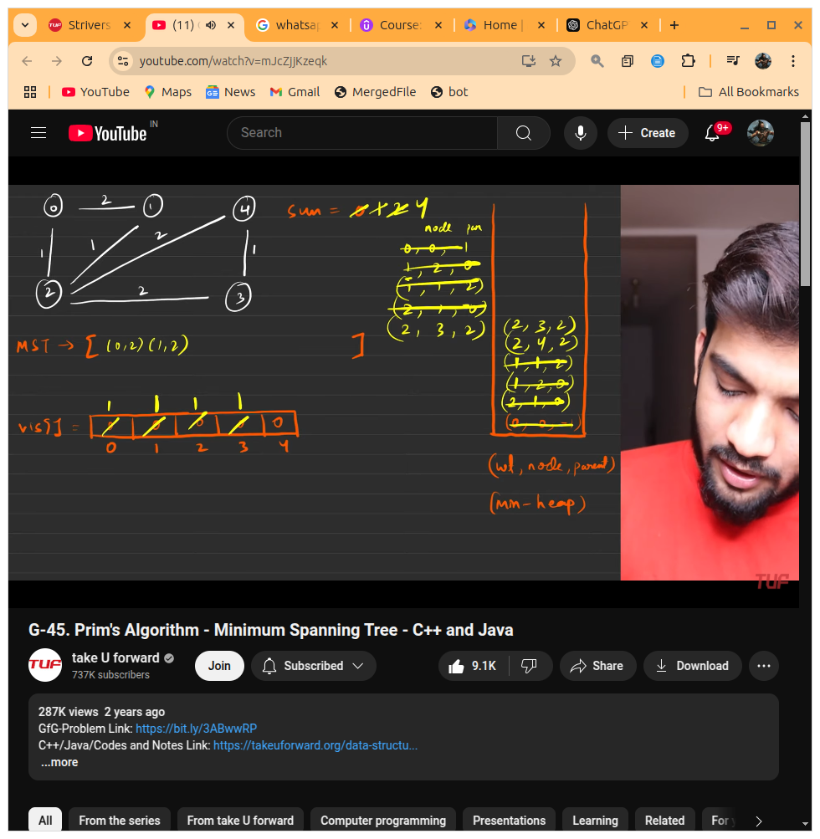
14. 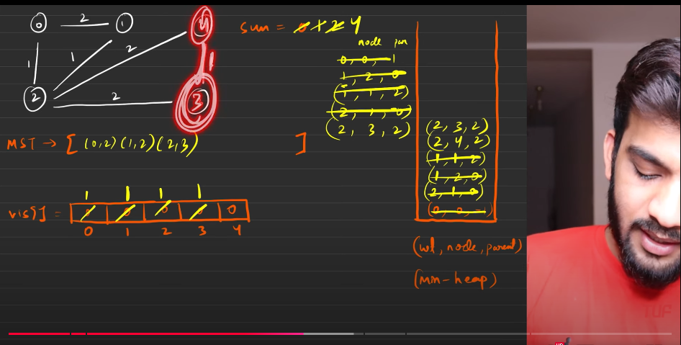
15. 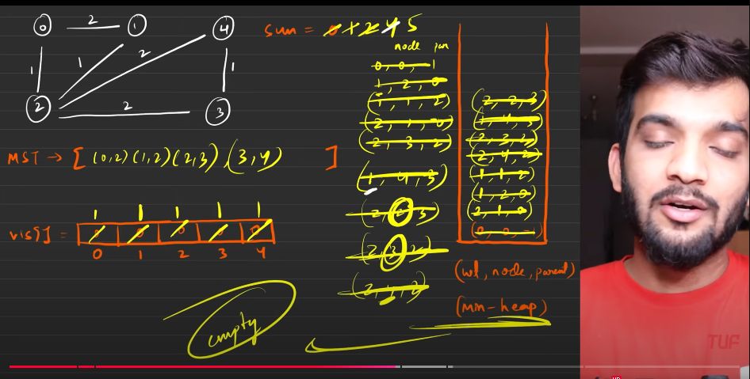
16. Algorithm:
    1. Make the initial configuarations:
       1. Insert the priority queue with the source node. {weight-on edge, {node , parent}} - wth the appropriate values to it.
       2. marks all the entries of the visited array as 0.
    2. Start traversing till the the graph
    3. If some one need the mst, then it is better we use the parent at the stack. else there is no need for making it.
    4. Add the current node and the parent into the mst list and then return when it completed.
    5. If they are intereseted only in the mst ost then add it , do nothing. return the sum at the end.
17. 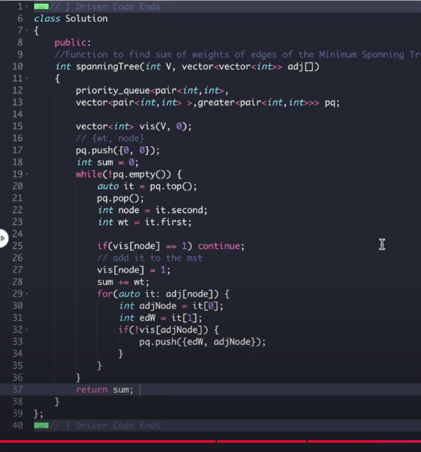
18. 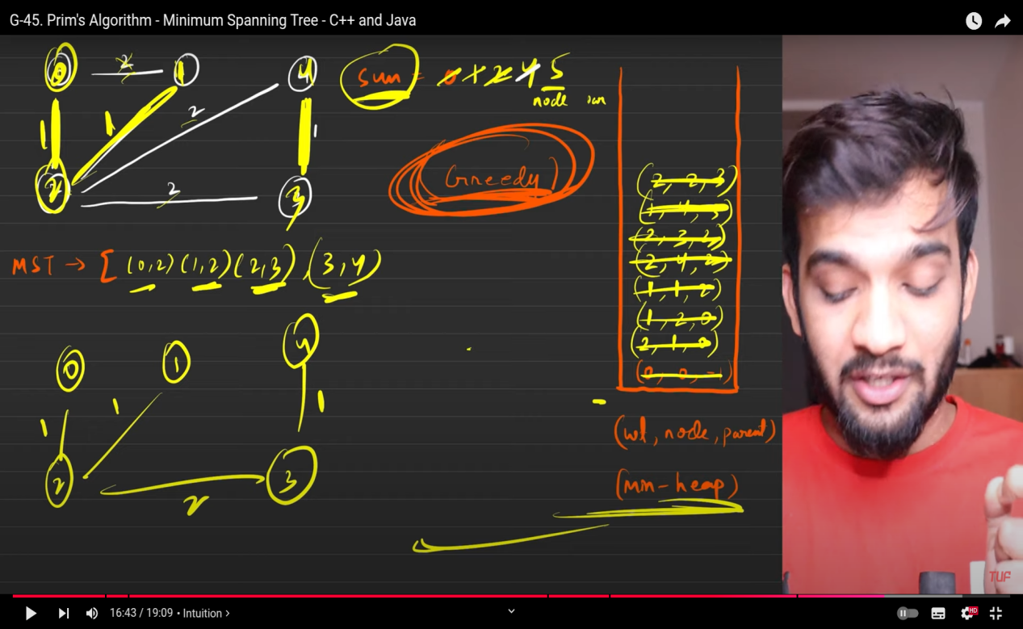
19. 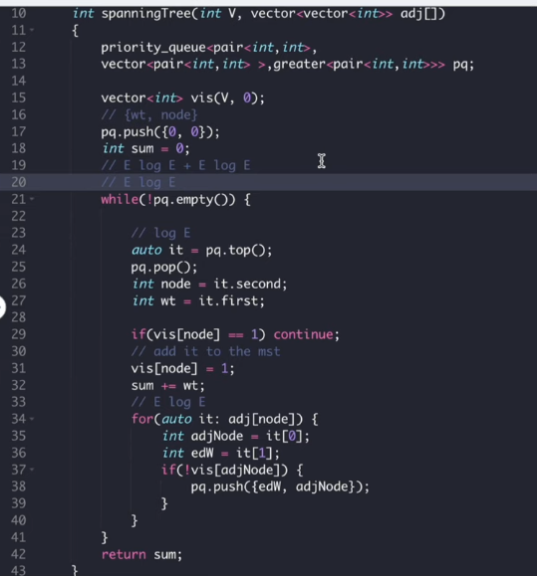

**Disjoint Set[VVV IMPORTANT] in graph series**

1. 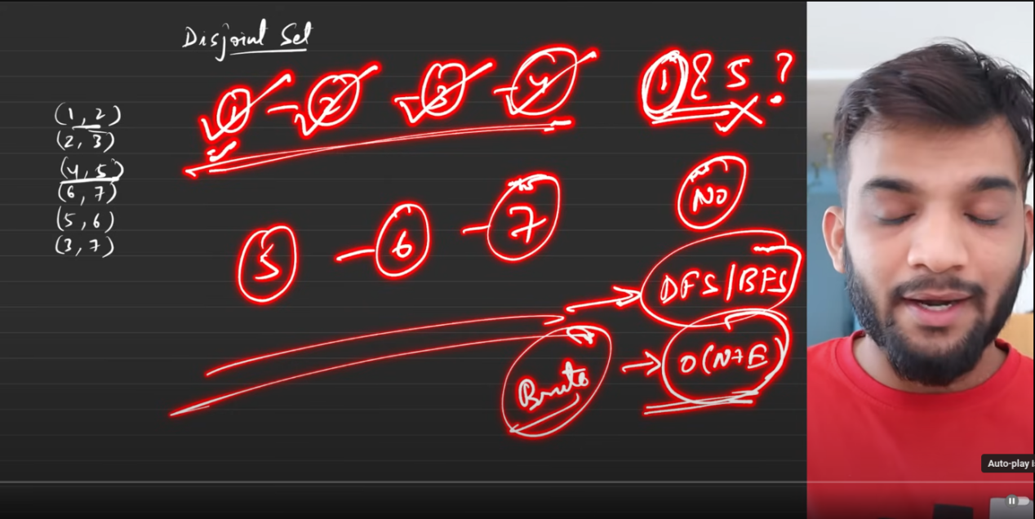
   1. Suppose when the graph and its components are given, will be asked , whether node 1 and node 5 belongs to the same graph or not??
   2. Then apply BFS or DFS check for it. If they are belonging, then true is returned.
   3. IF not then it will return false.
2. But the aboe is going to consume O(V+E) if disoint set is used then that tells whether the nodes belong to the same component or not within O(1) time.
3. This is mainly used for 2 questions:
   1. What is the parent node?
   2. Union by using rank and size.
4. Union is used for connecting between the nodes.
   1. 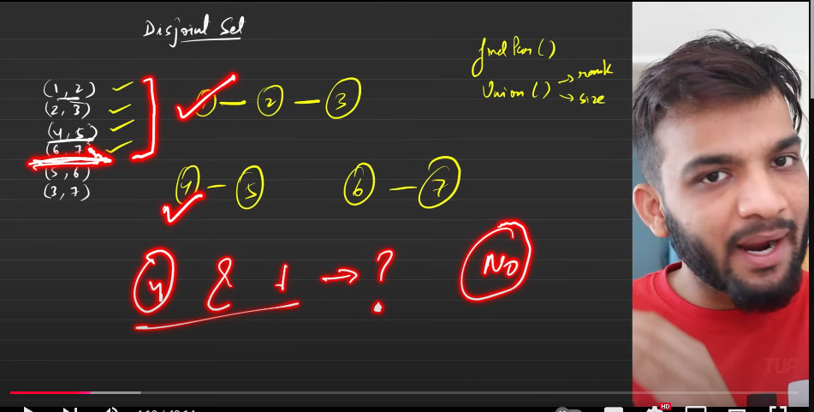
   2. 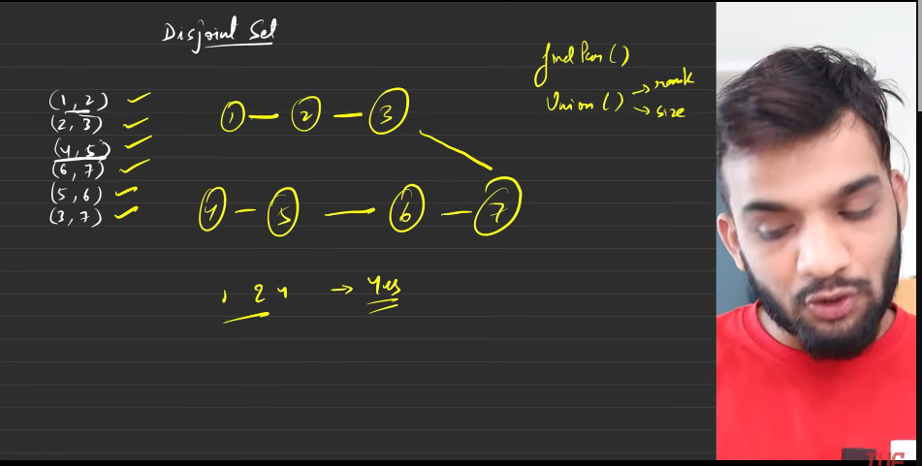
5. Initial configuarations:
   1. 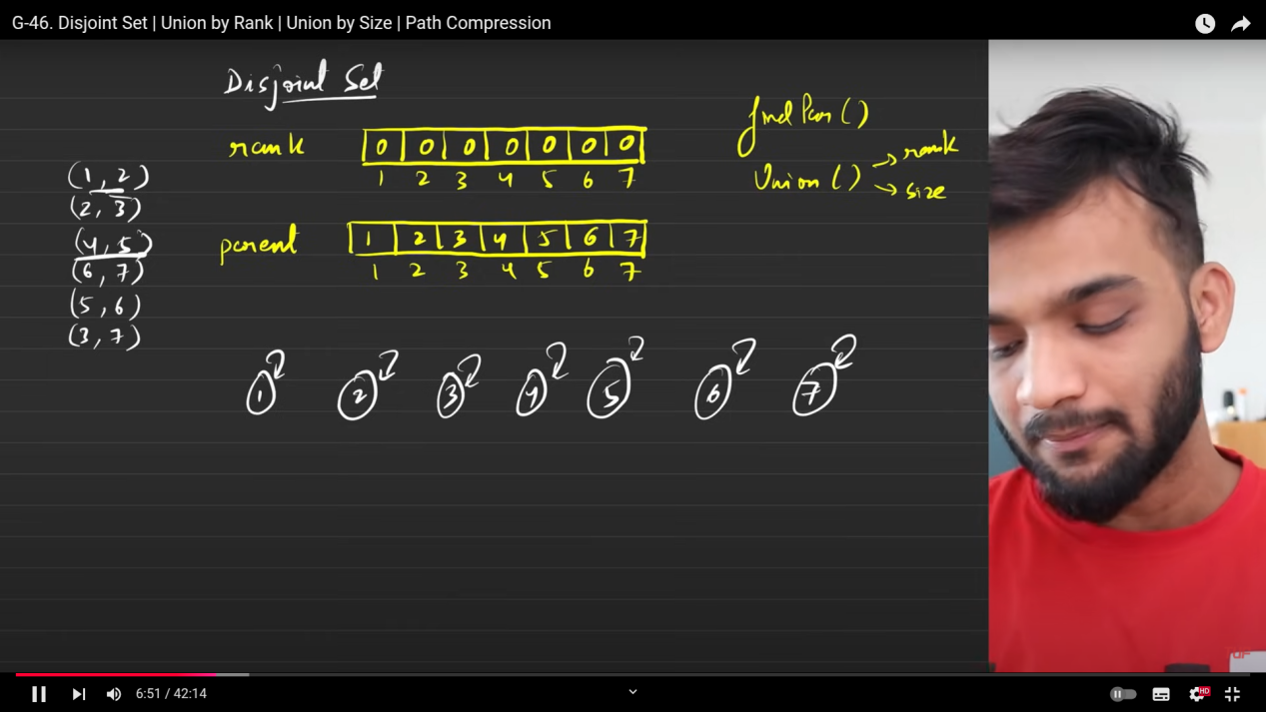
   2. rank array: There is no one below at the starting hence the value of the rank at each index is equal to 0.
   3. Parent array: The node which are above the current node.
   4. 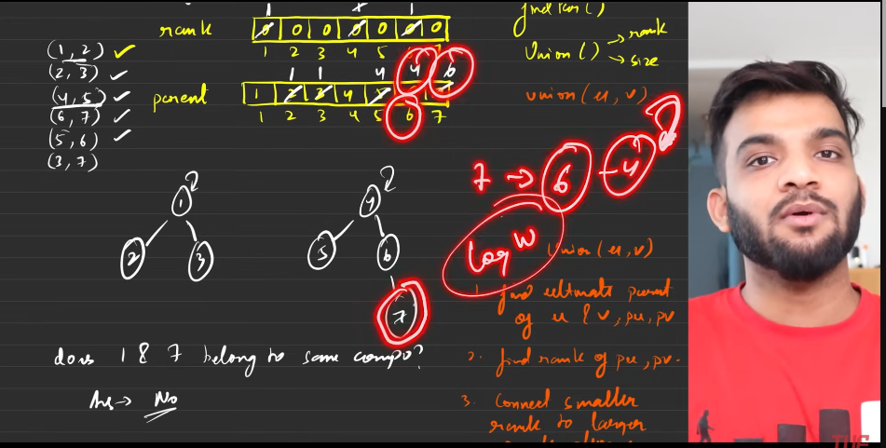
   5. But finding the parent of the super parent of the node consumes O(logn) time. Hence it is not able to find whether the 2 nodes belong to the same parent or not. To check that we need to use something called path compression.
   6. **Path compression**: Instead of mkaing the connection onlty between the parent and the ndeo, we are making the connection directly with the super parent even for grand children reason is to find whther the 2 nodes belong to the same graph or not. Need to consider.
   7. 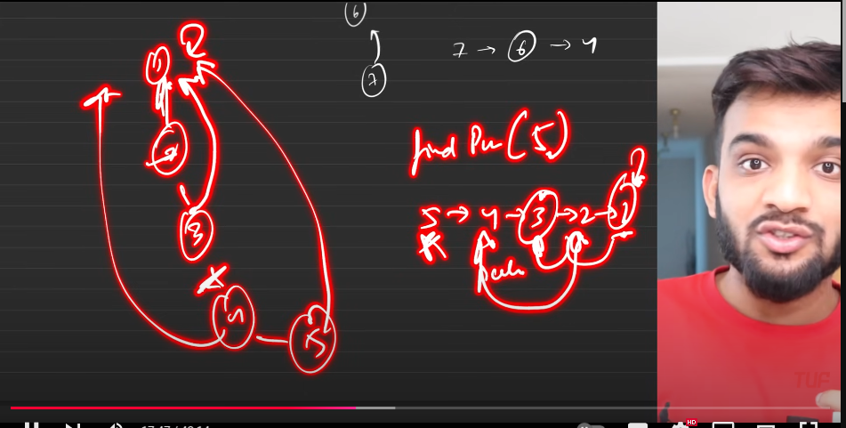
   8. 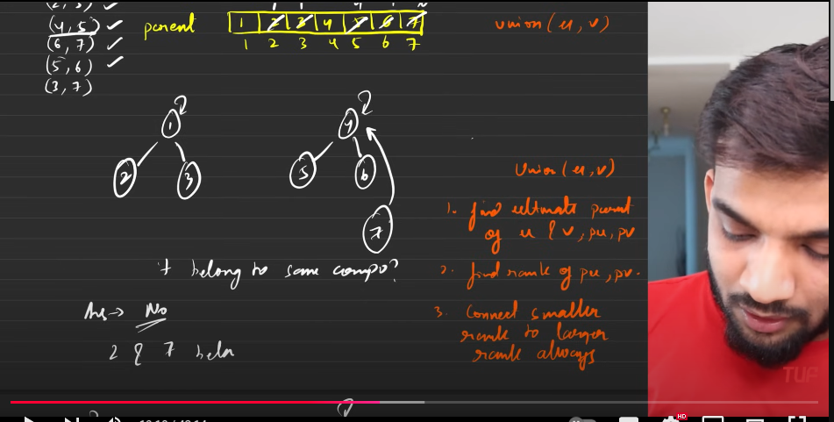
   9. 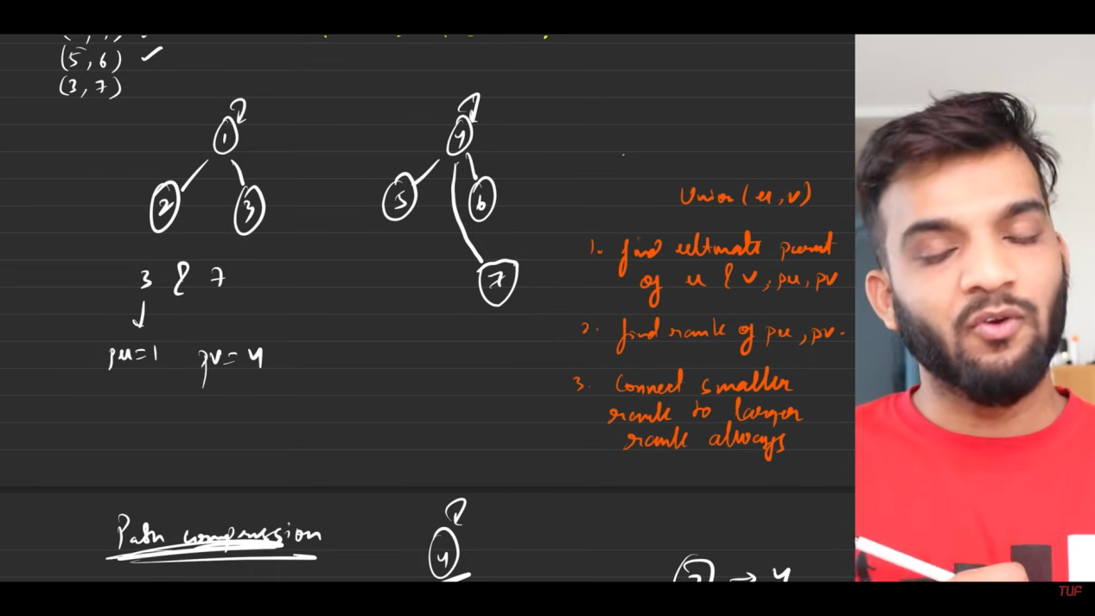
   10. 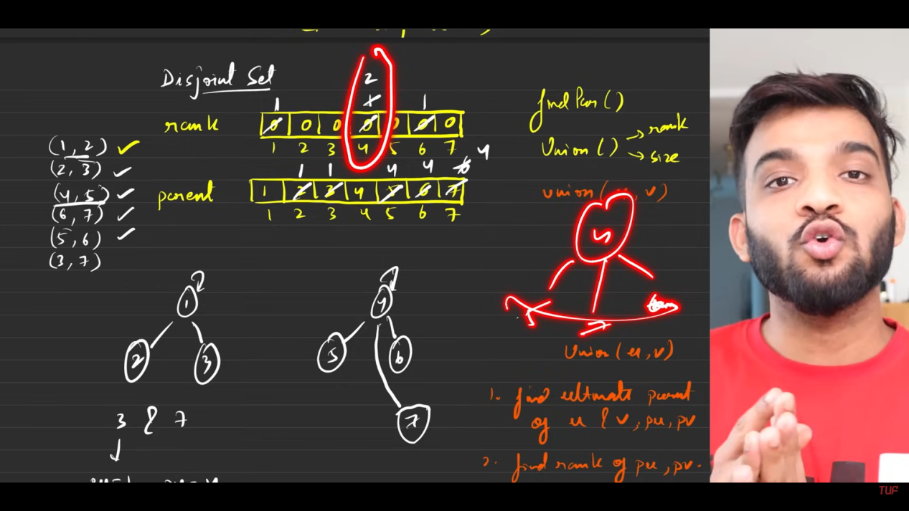
       1. Problem with above
   11. Rank speaks who is bigger.
   12. 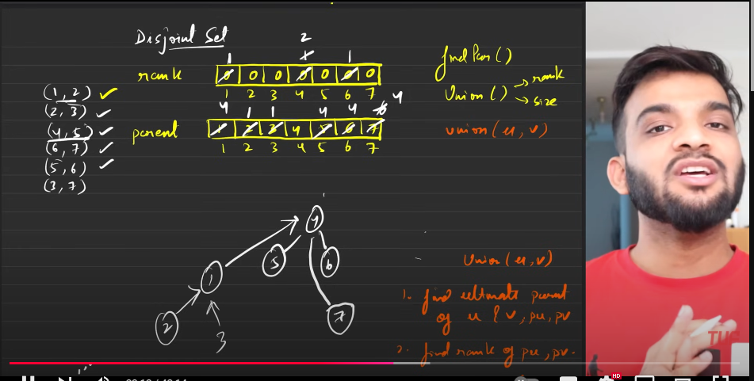
   13. Path compresiion occurs only afetr calling the findparent(node), before that it will not happen. Hence keeping the rank as same
   14. 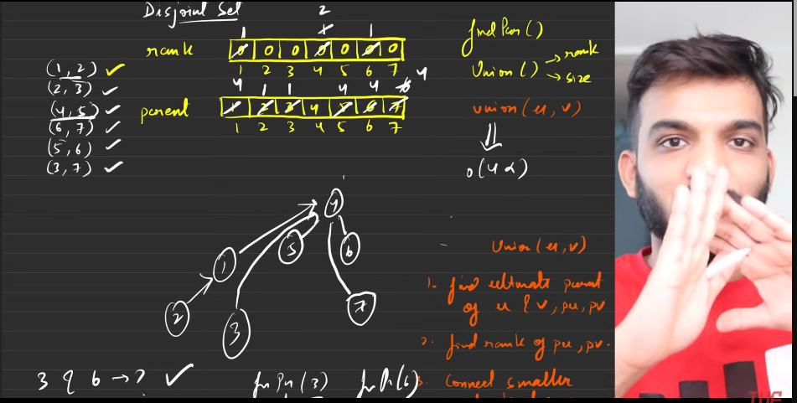
   15. The time complexity of Union is 4*alpha, which is as close as O(1).
6. Path compression:
   1. 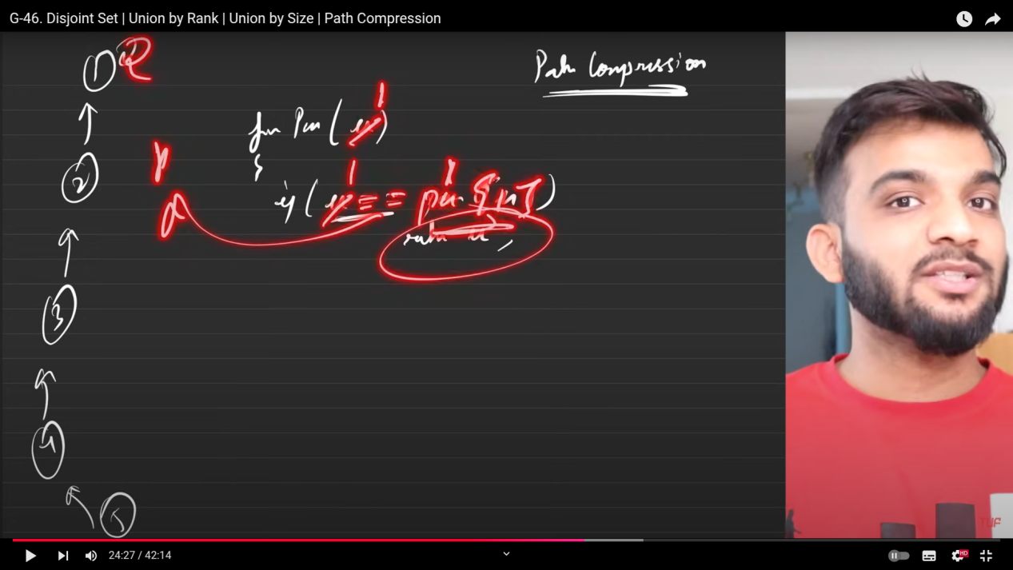
   2. 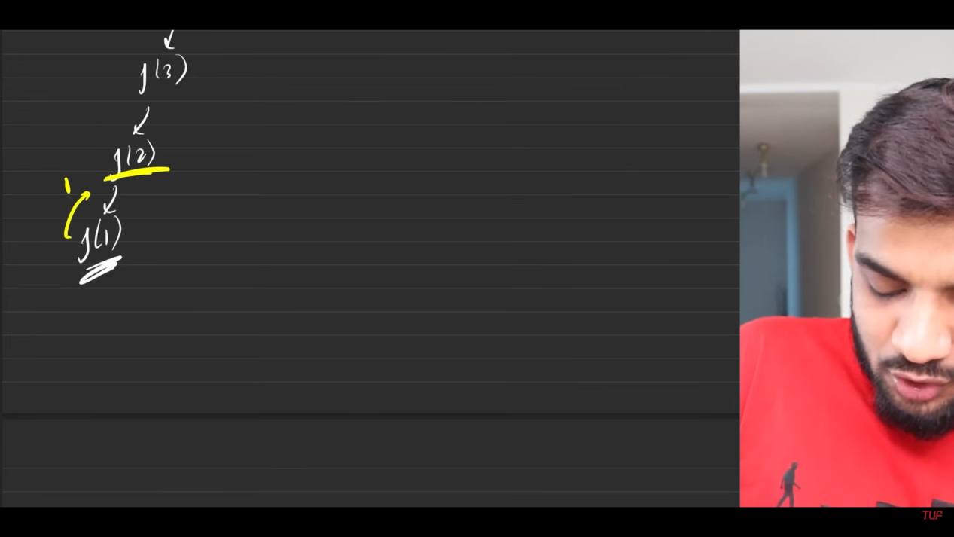
   3. 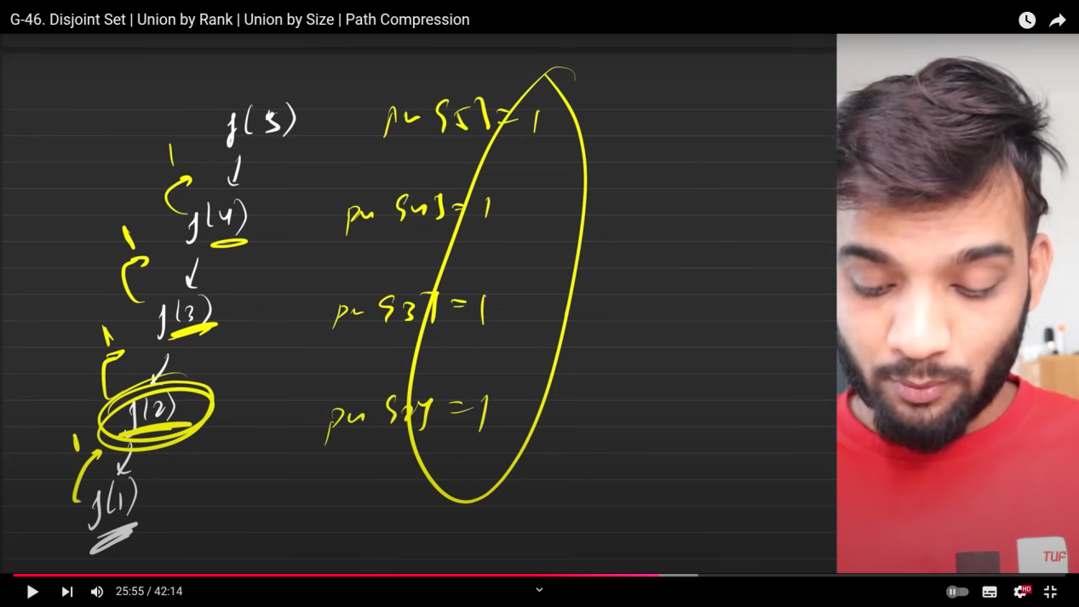
   4. 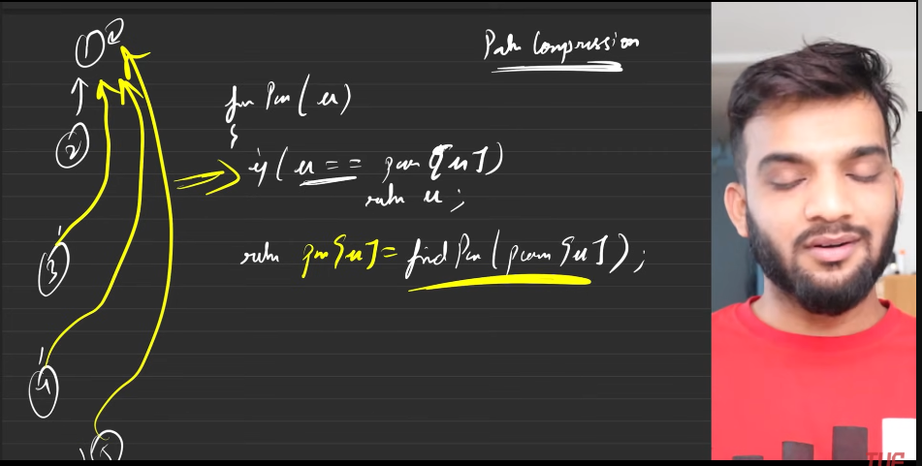
   5. 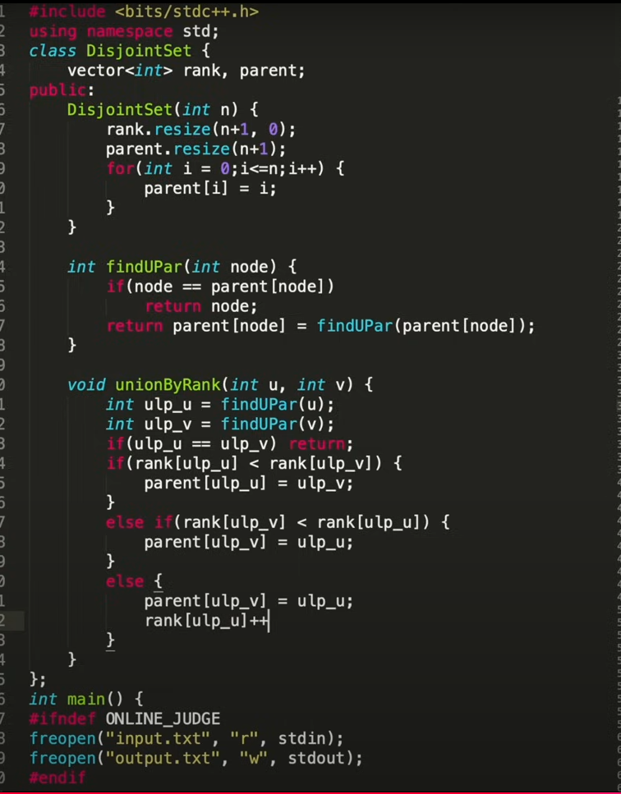
   6. 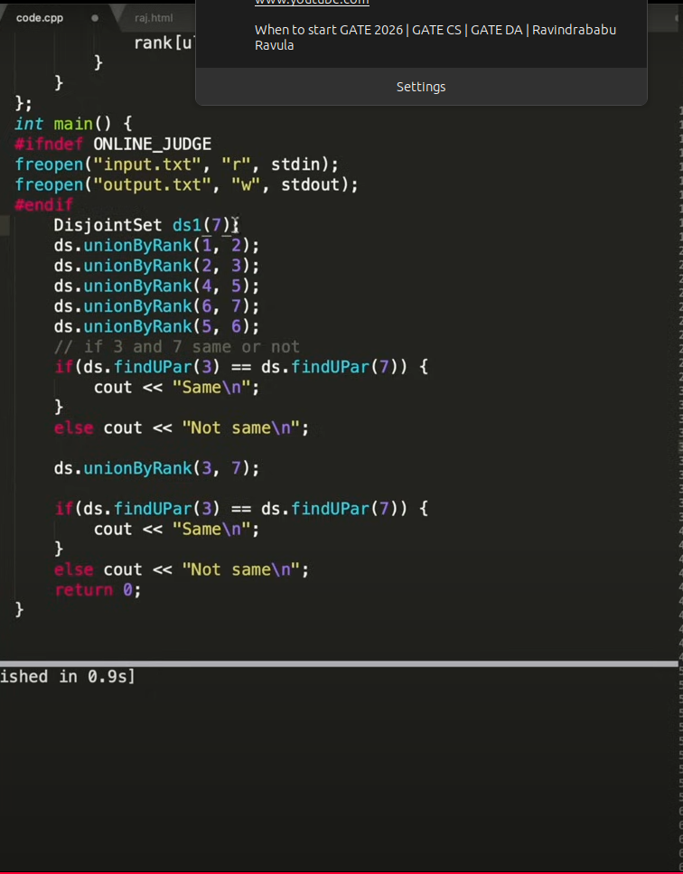
   7. 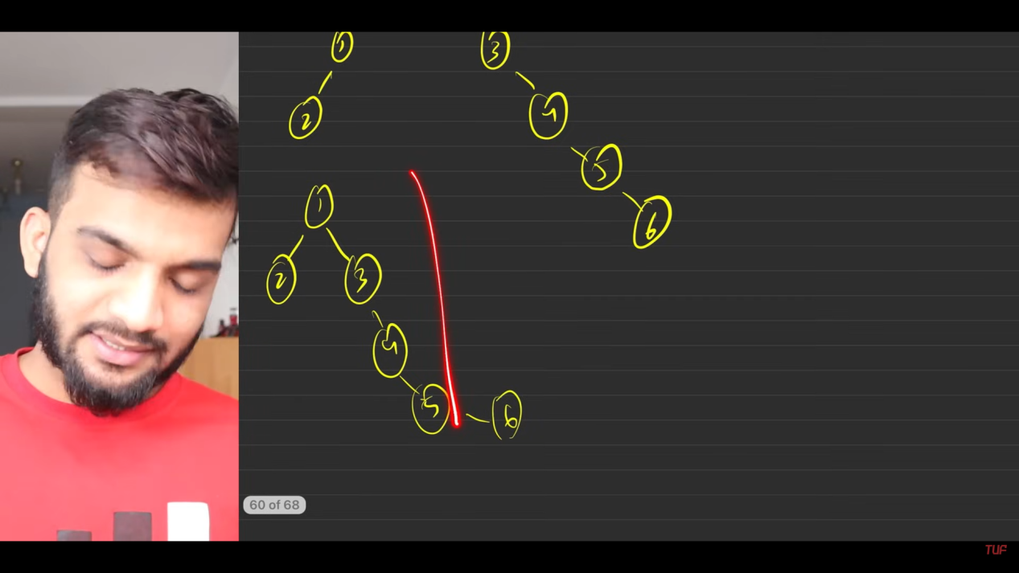
   8. When we are connecting the higher rank with the lower rank, then the height of the grah gets inreased, which will effectively increases the time for finding the ultimate parent. We are considering smaller number of nodes here. But this is not in the original numericalls they will be having hell lot of nodes. Therefore we have connect the lower rank with the higher rank.
   9. 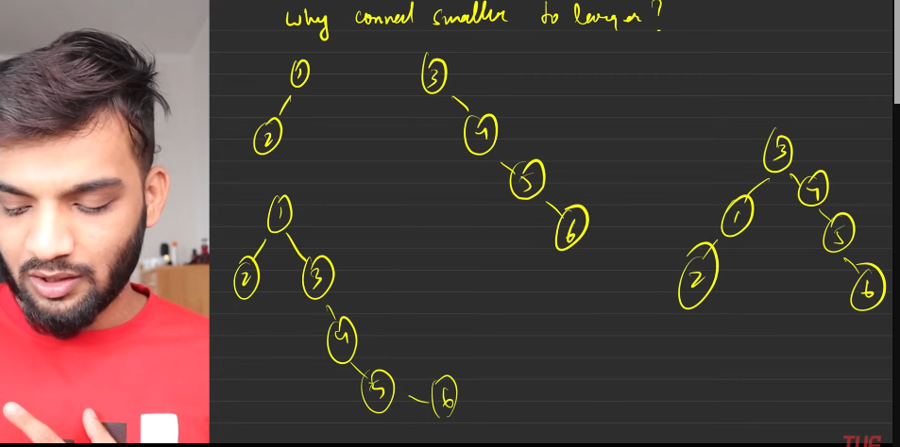
   10. 2 reasons for attaching the lower rank to higher rank node i this alogrithm:
       1. To shrink
       2. To reduce the time traveling during path compression.
7. **Union By size**
   1. 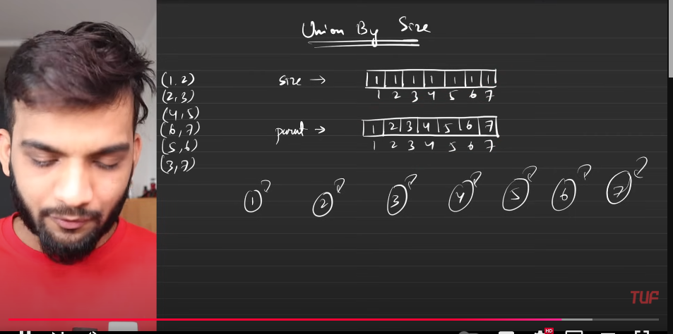
   2. 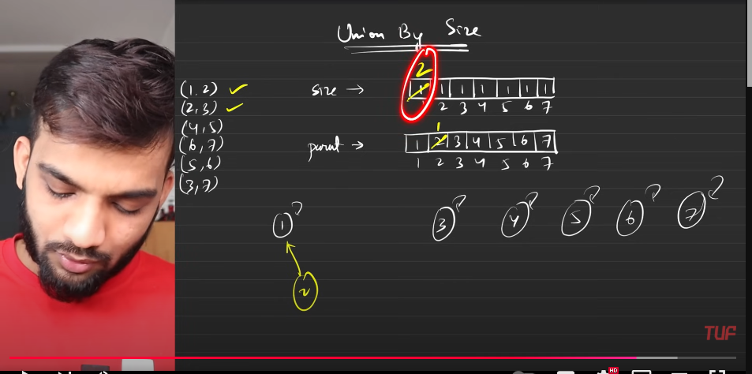
   3. 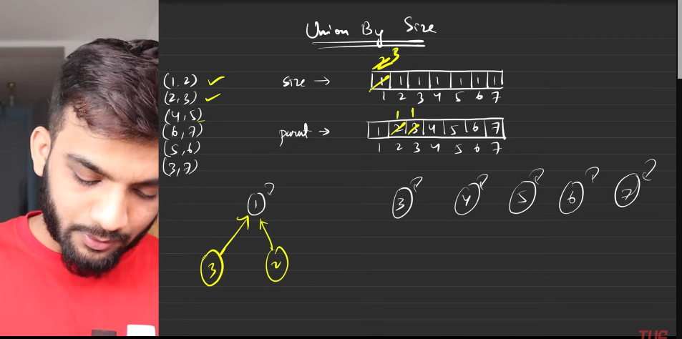
   4. 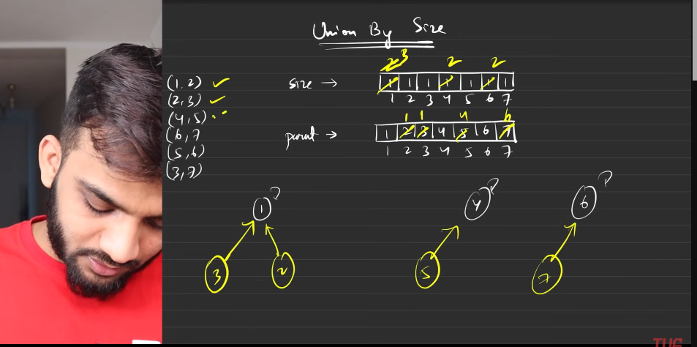
   5. 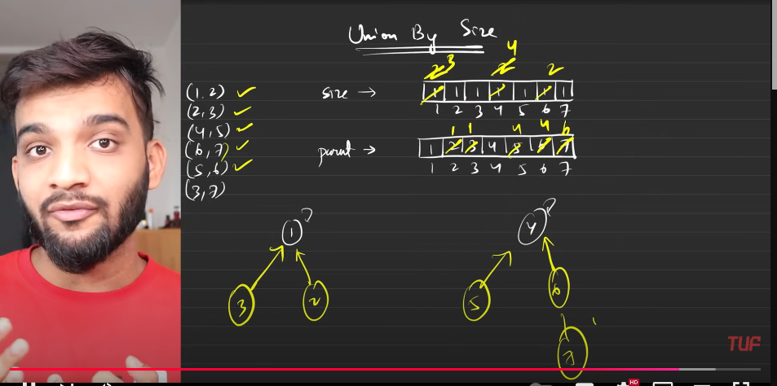
   6. 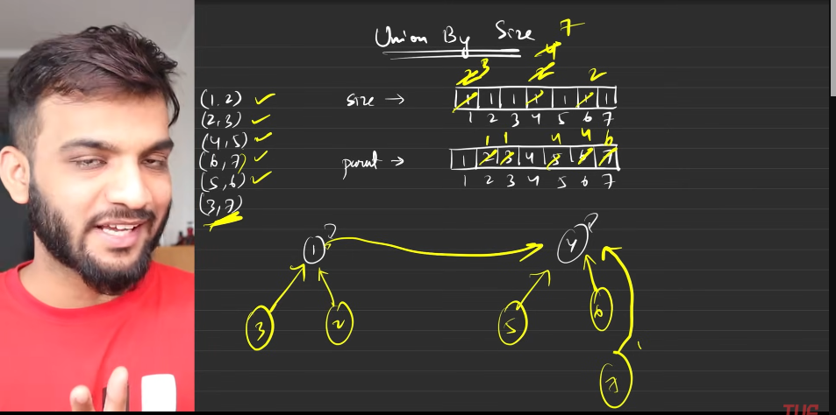
   7. 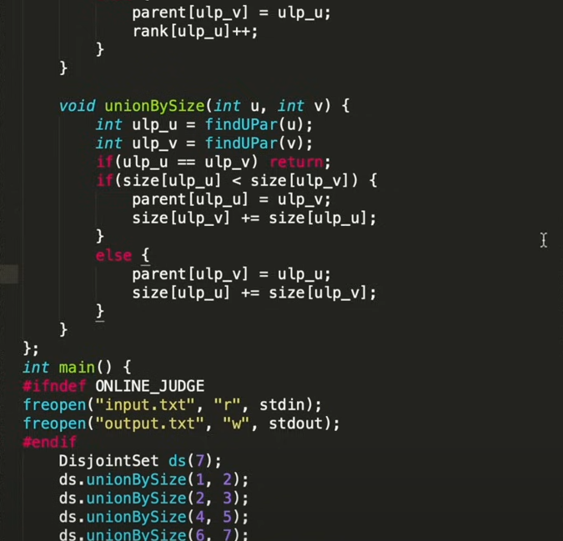
   8. 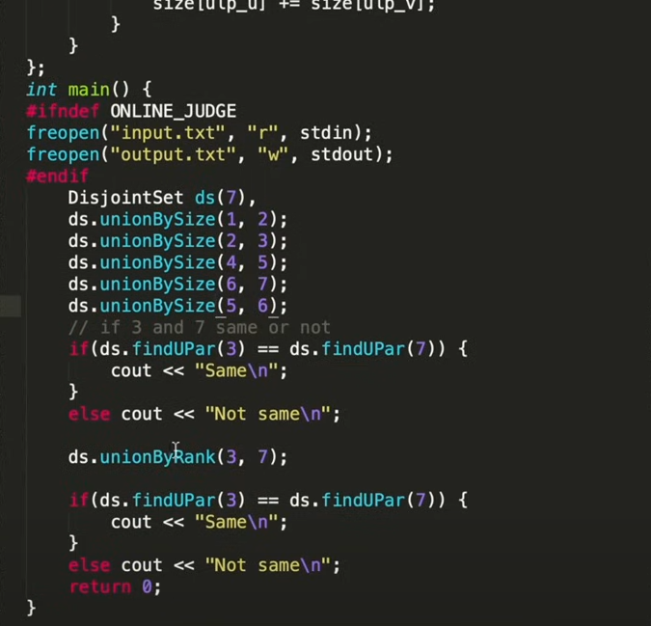
   9. 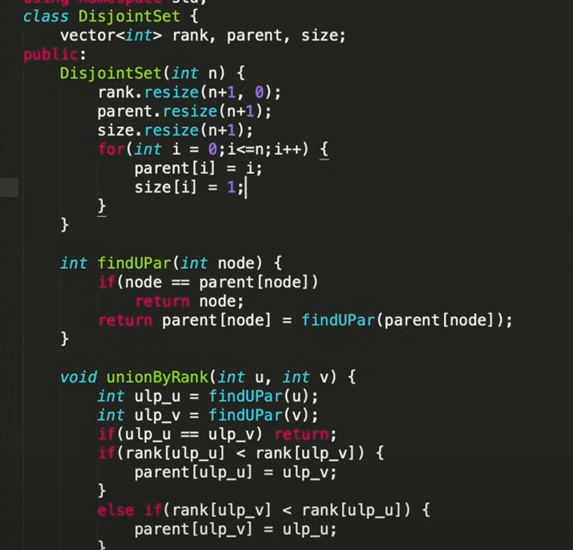
8. Explaining these algortihms in my ow way:
   1. Find whether the 2 different nodes belong to the same parent(**path compression alogrithm**)
      1. We will be having the superior parent array/vector, which is having the the parent of the current node.
      2. We need to tarverse till the (node == parent[node]), since the parent of node can be the same only when the root is node.
      3. Then change the parent[node] = findparent(parent[node])), this need to be returned.
   2. Union algorithm:
      1. initial configuarations:
         1. Rank with all the nodes to be zero.
         2. Parent with all of them are self parents.
      2. if rank[u]<rank[v] then we will attach the node[u] to node[v], the lowered rank will be attached to th ehigher rank. Just need to chang eth eparent. So that the height will not change.
      3. if equal then any one can be parent, but the one who becomes the parent, then that guy’s rank will be increased by one.
      4. This keeps on hapeninng till the node seuqnce are present.
   3. FInd Union By size:
      1. Initizalison:
         1. The size array,elements of all the nodes will be initlaisde by one .
         2. parent will be same as the nodes.
      2. if the parents are same then we do not do anything. But if the parents are same then we attach the parent of node with other node by chnaging the parent node.
   4. s

**Kruskal’s Algorithm**

1. 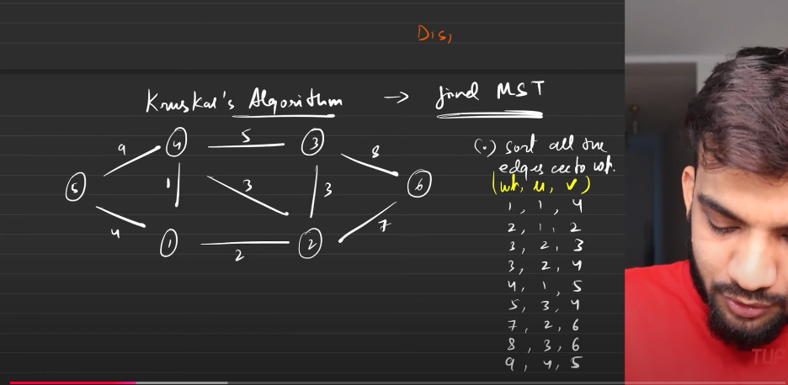
2. 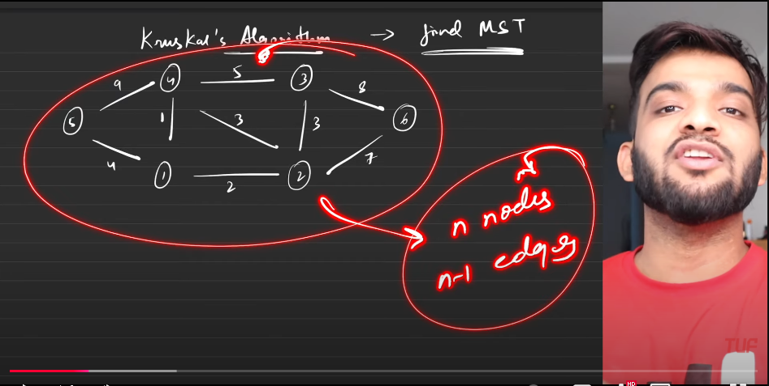
3. 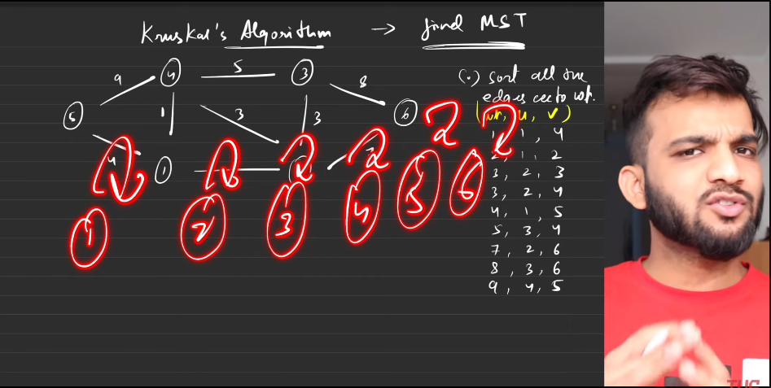
4. 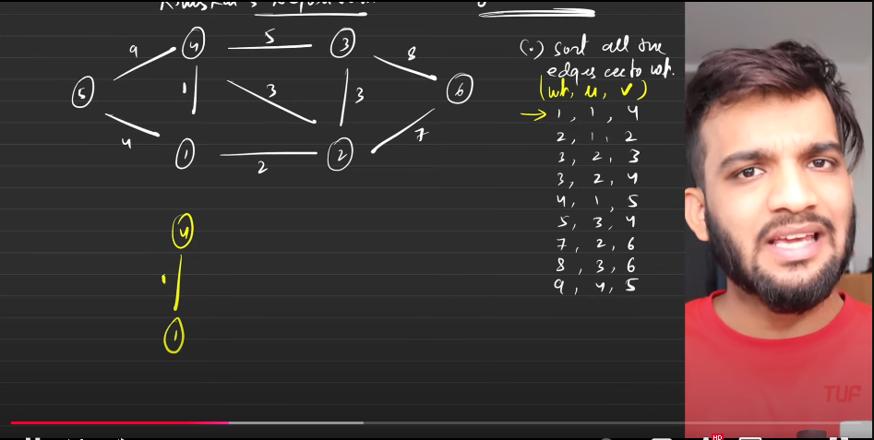
5. From disjoin set we check hether the nodes belong to same component or not?? If not then we will add the 2 into the component
6. 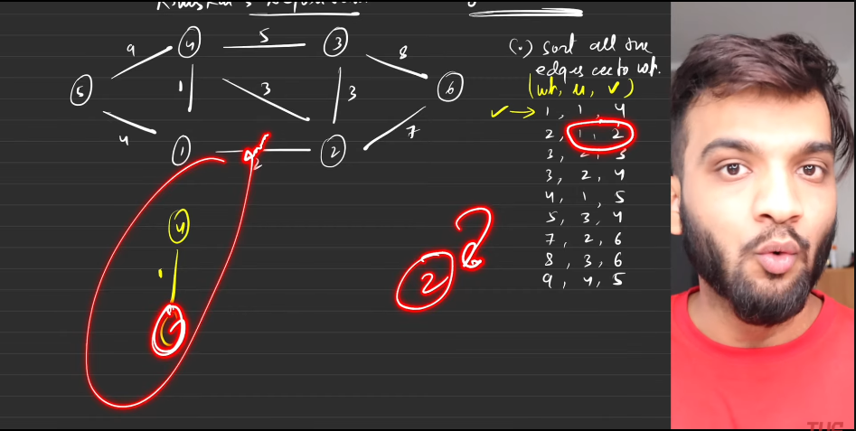
7. 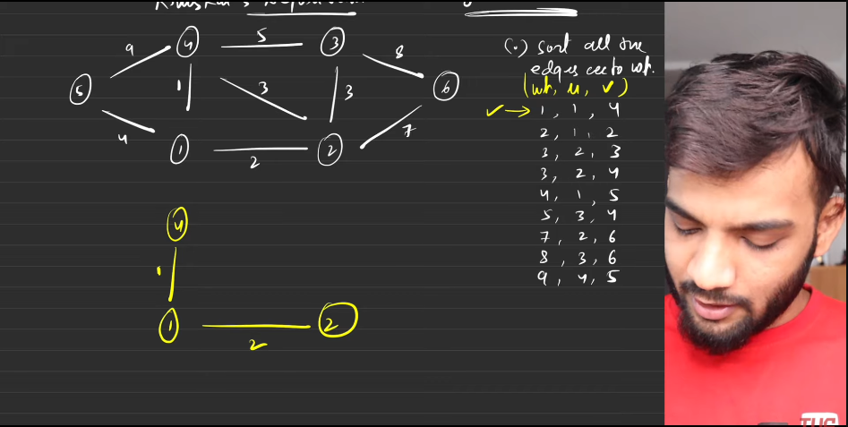
8. 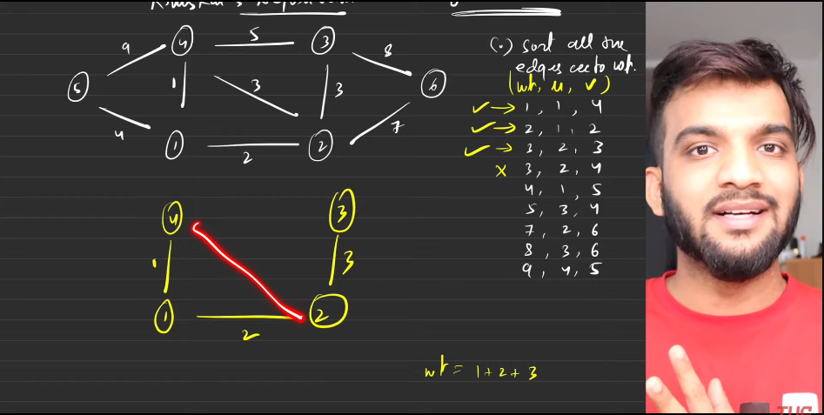
9. 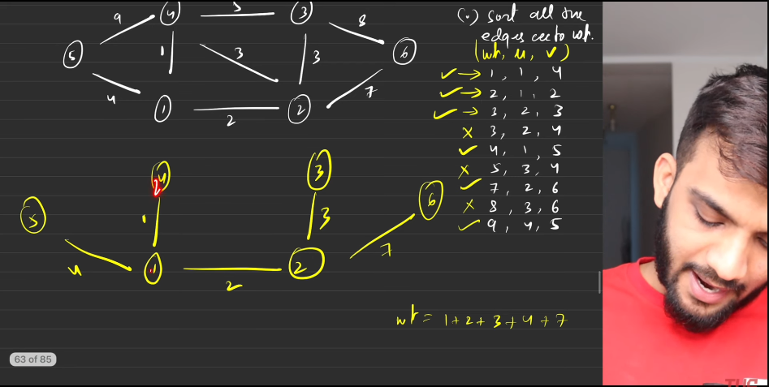
10. 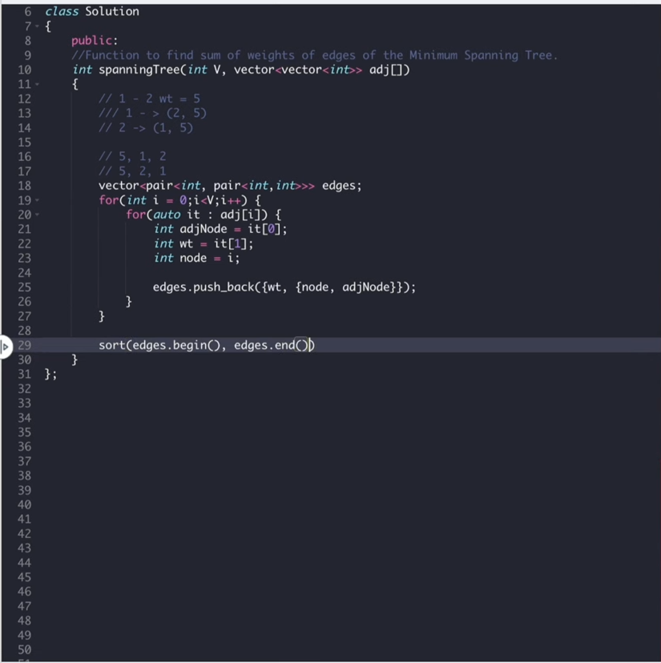
11. 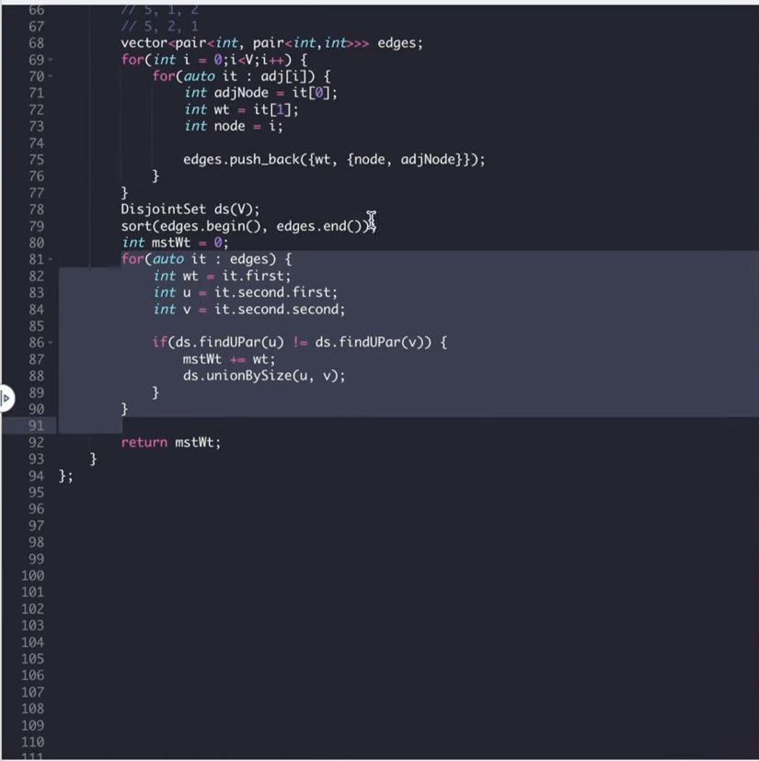
12. 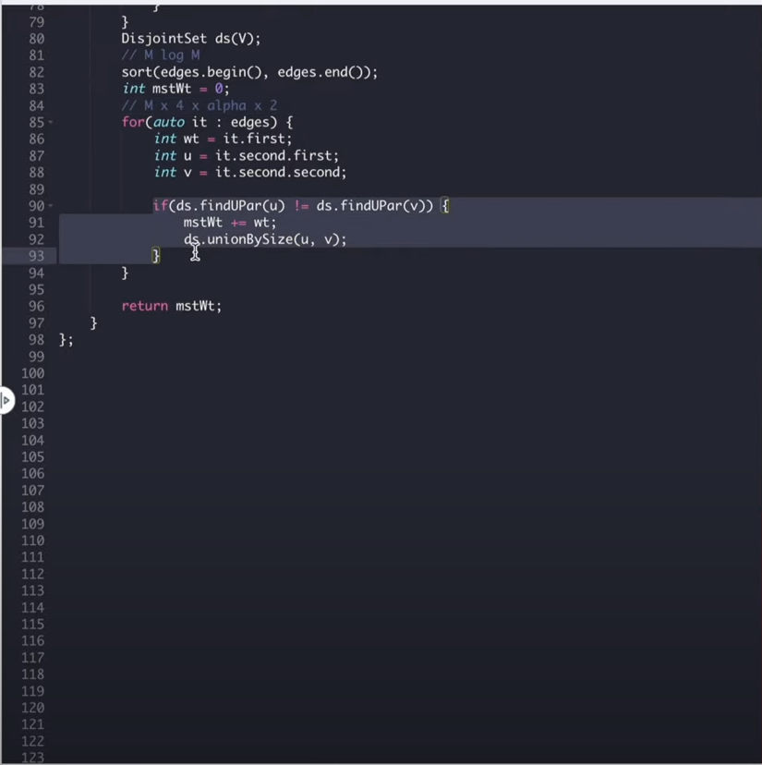
13. Kruskals algorithm in my own way:
    1. This is used to make MST from the given set of edges.
    2. arrange the edges in the srted fashion.
    3. Initialize the number of vectirces to the disjoint set, which initialises the size, rank, ultimate parent array.
    4. Once it is done, start taking the edges oe after the another in the sorted array. Check the 2 node u and v has the same parent or not.
    5. If they have same parent, then do not join them, else join them, By making the MST added with the weights.
    6. return the MST.
    7. You can use the disjaoint set either by the size or by the rank.

**Number of Operations to make the graph connected**

1. 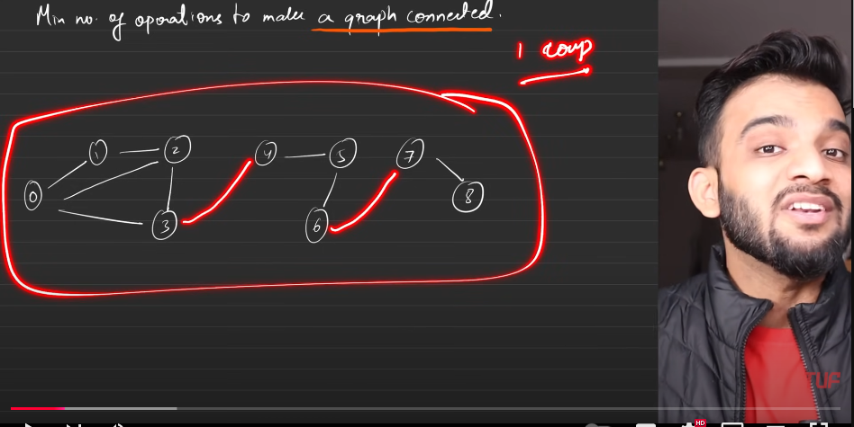
2. Condition is you cannot make imaginary edges, instead you have to take it from somwehere else.
3. 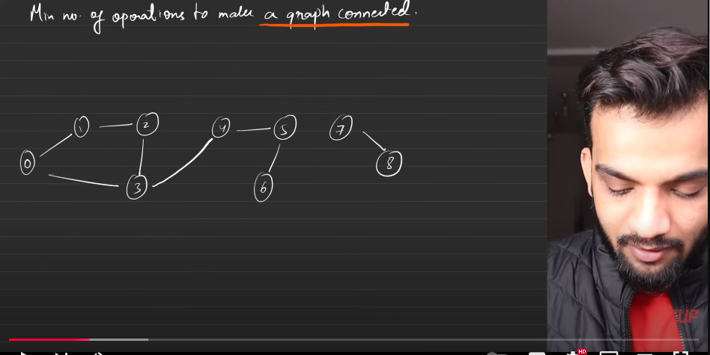
4. 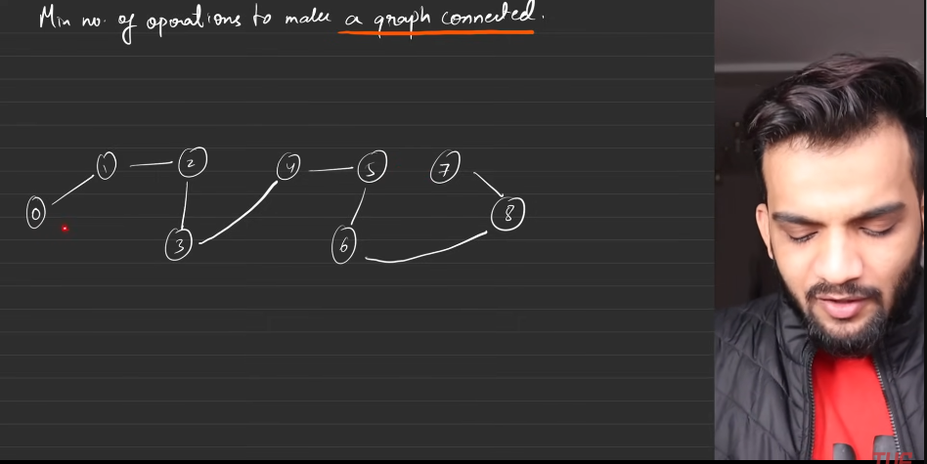
5. The graph is still connected.
6. 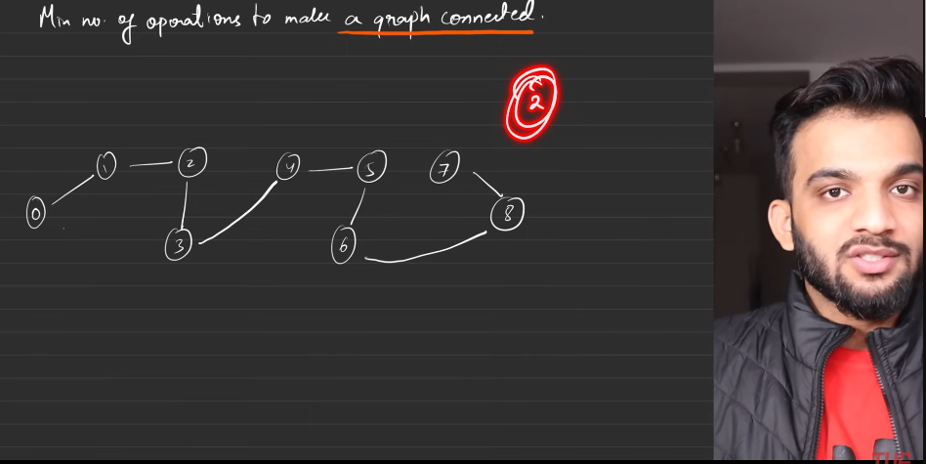
7. 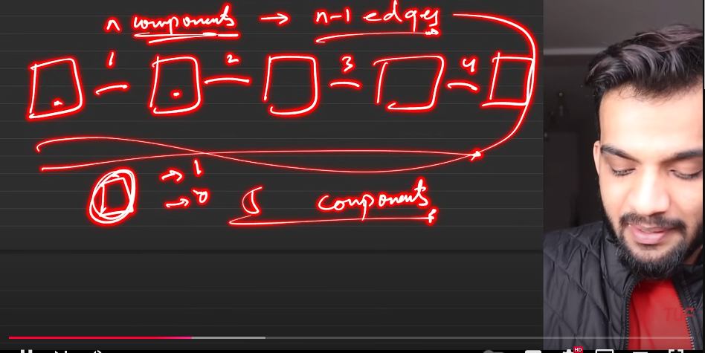
8. 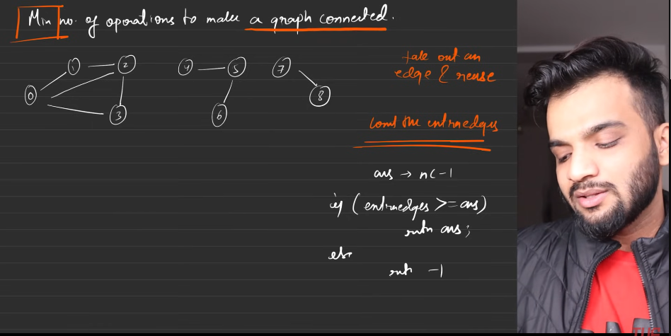
9. 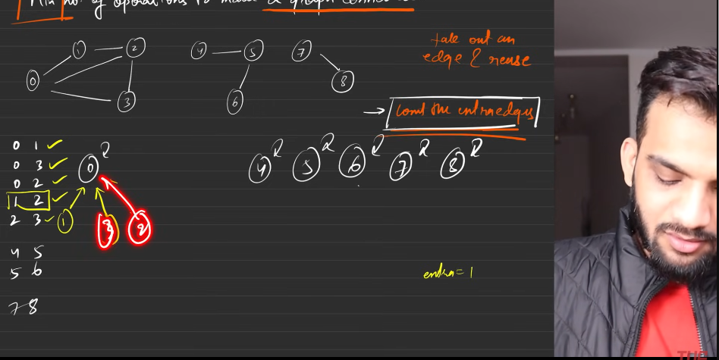
10. 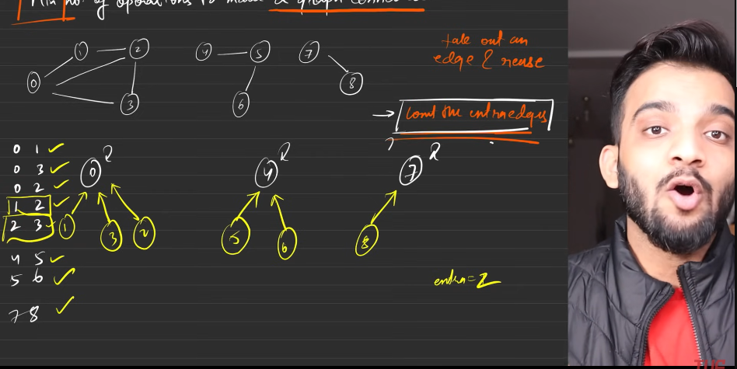
11. 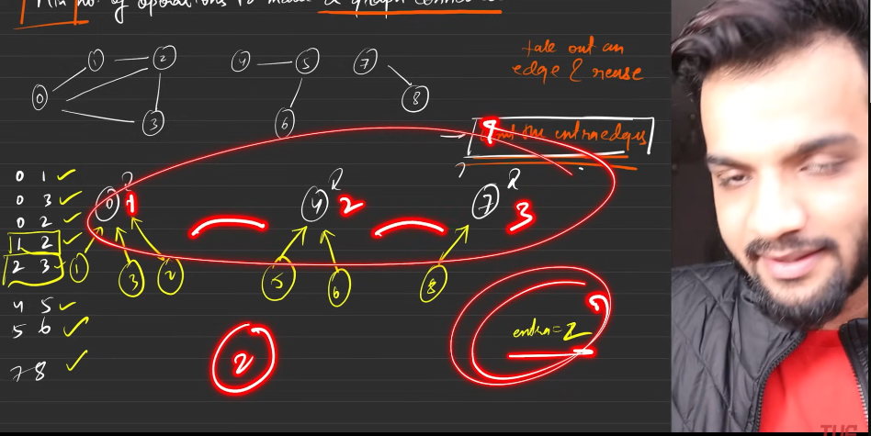
12. 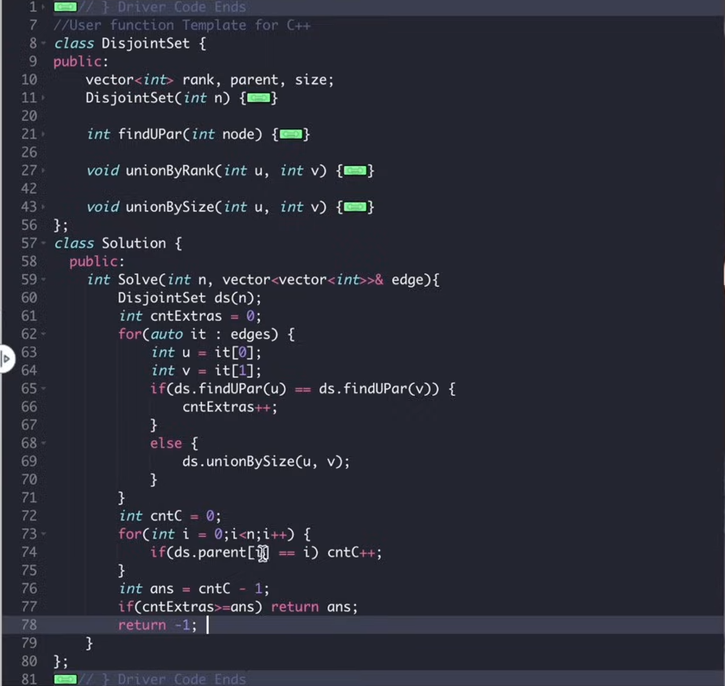
13. My way:
    1. Assuming that number of components(graphs) is already given.
    2. Here I’m not interested in making the MST, so use the set of edges start making the Tree.
    3. If the parent of 2 different nodes are seen as same then do not add that into account consider it as extra edge.
    4. Else keep making the graph.
    5. Extra found is greater than the number of edges then we will have to count the number of connected components and find the number of edges required is 1 less than number of components.
    6. Else return -1.

**Most stones Removed with Same Row or Same Column**

1. 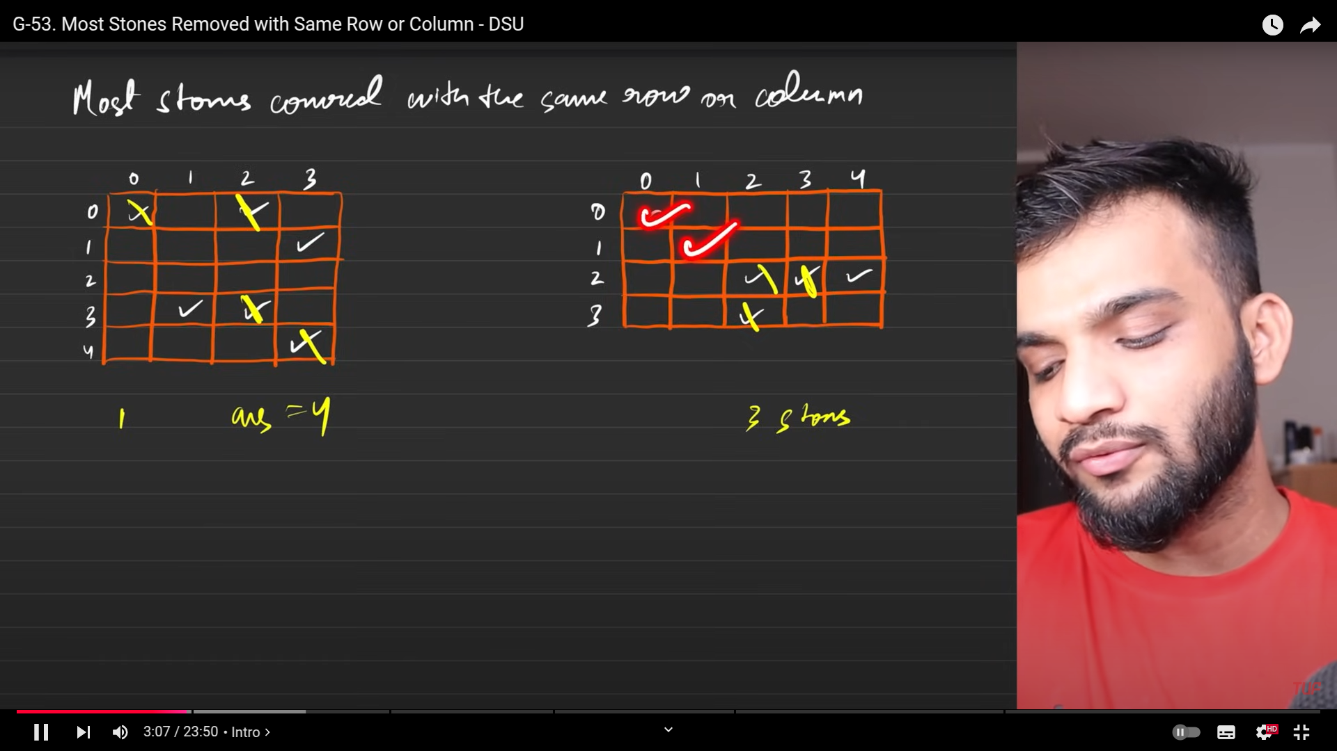
2. The one which are having same row or same column will make the same component.
3. leaving only one node in each component and removing all other nodes, the summation with all other componets, after making the graphs comonets will make give the answer.
4. Algo:
   1. From the given set of vertices, make the graph and from these components if it has **n** number of nods, start removing n-1 number, keep adding with all the components made. Then rteurn the answer.
5. 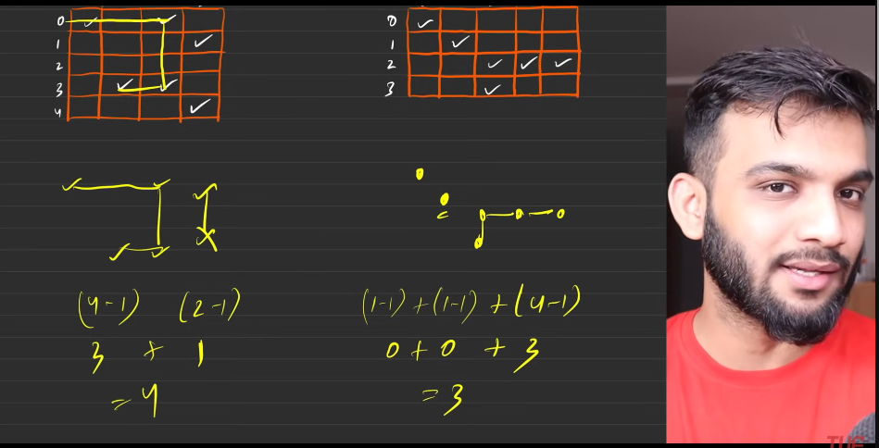
6. 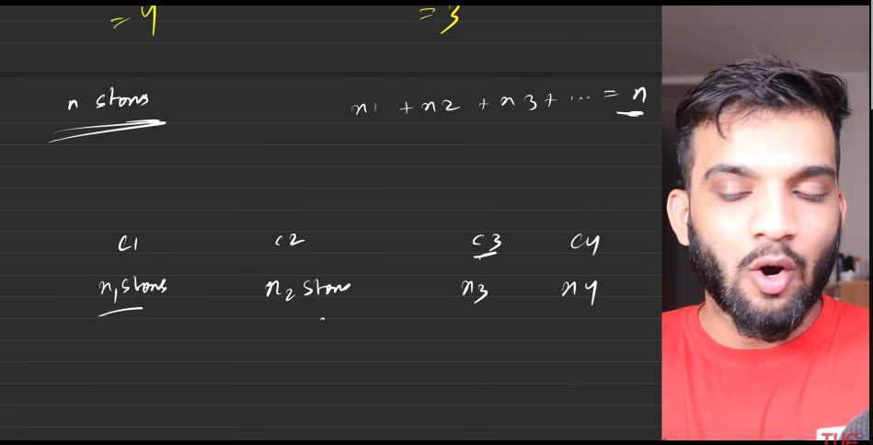
7. 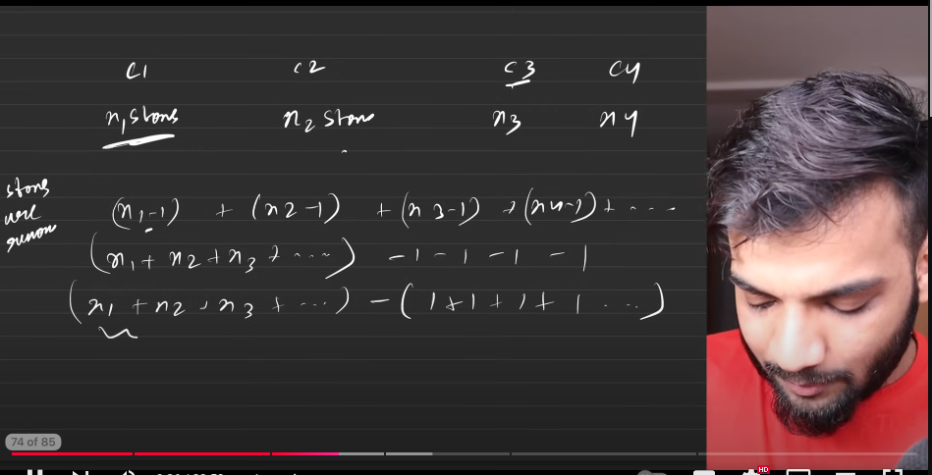
8. 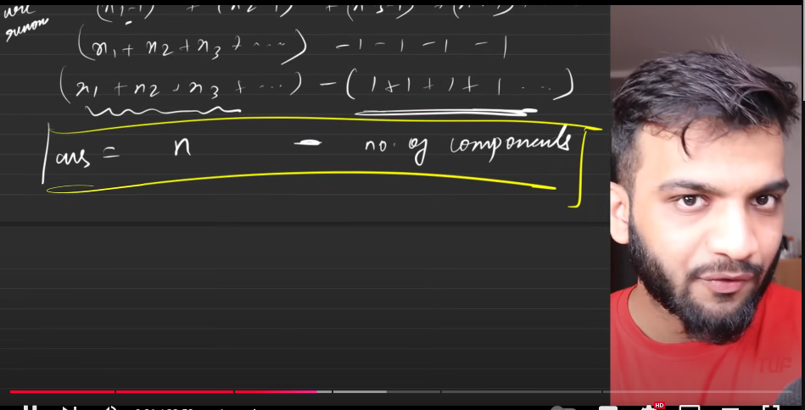
9. Whenever you listen to the conneceted components, 2 kinds of algorithms comes to mind:
   1. Traversal algor
   2. Disjoint sets.
10. 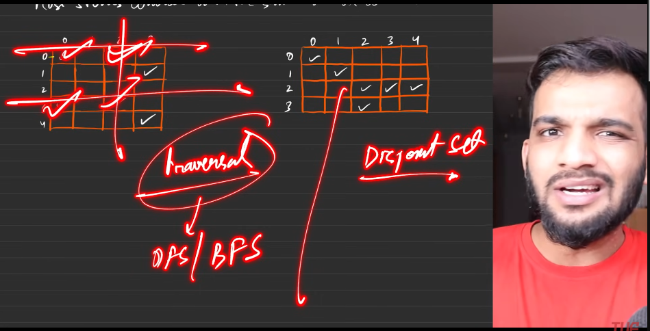
11. 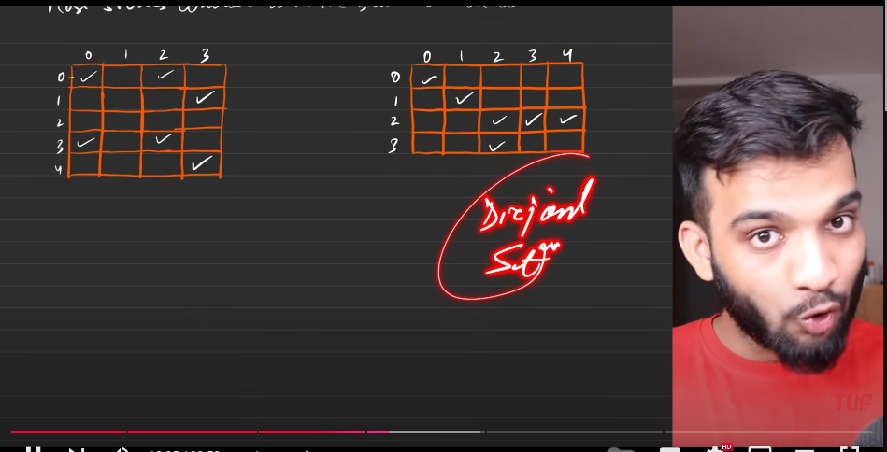
12. 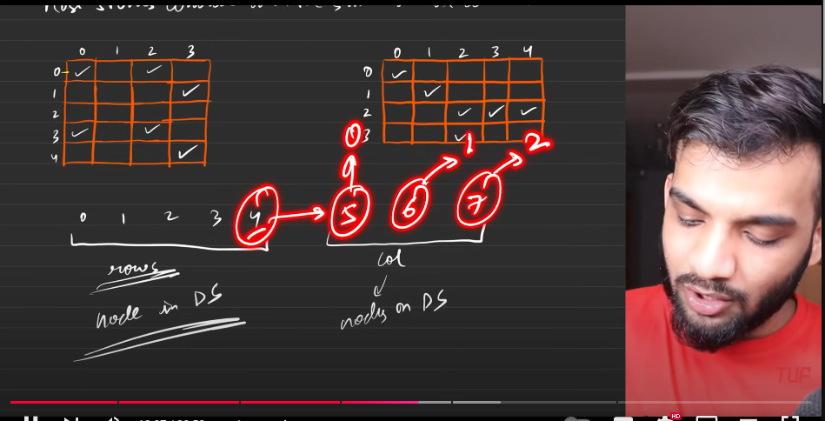
13. 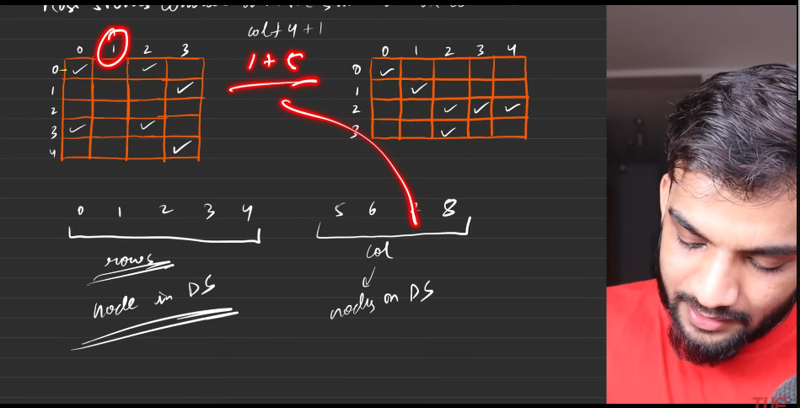
14. Here each and every node represenitng the row and the column.
15. Now connection part.
    1. Just write the line on row and the columm, if you find the intersection with any tick marks. Then connect the nodes if they belong to sepearte components.
    2. Above is how:
       1. Start iteration:
          1. choose a row
             1. Start tarvelling the column of the grid, if you find any tick marks

Check whether node->row, node-> column are belonging to sepearte components. If so then we add it. Else leave.

Simulatnoeosul collect the number of tick marks and connected components.

Remove the invalid disjaoint sets.

* + - * 1. Finally return the **(number of tick marks) - (connected components)**.

1. 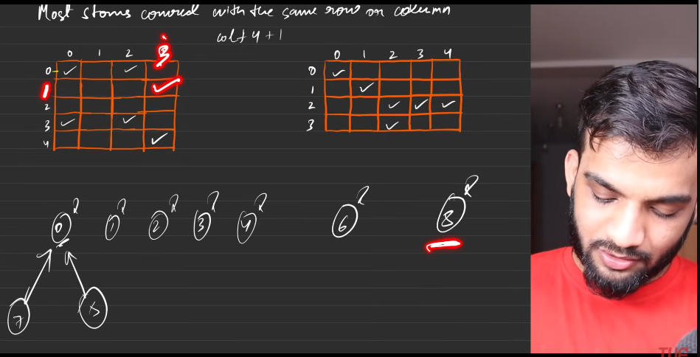
2. 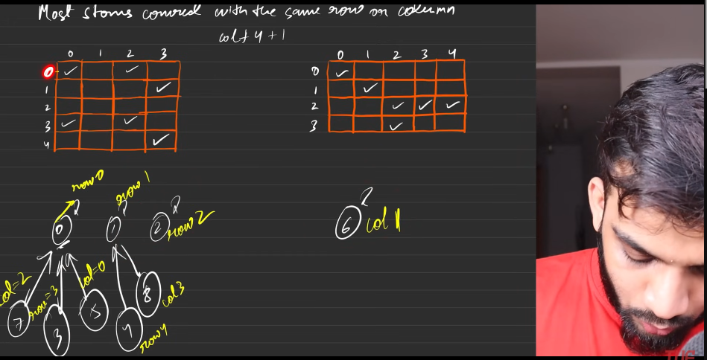
3. 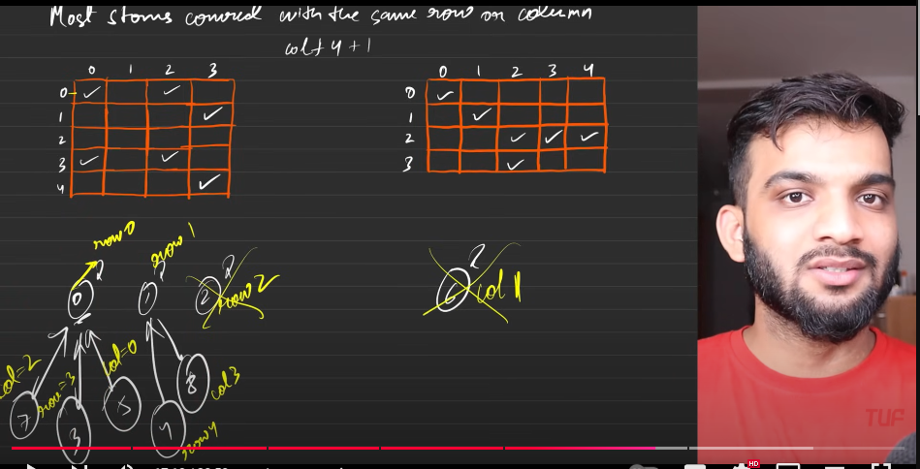
4. Invalid disjoint sets: The row or the column will not have the elements in it.
5. Tow uniqu ultimate parents. Number of ticks .
6. (remove the number of ticks)- (utlimate parents).
7. 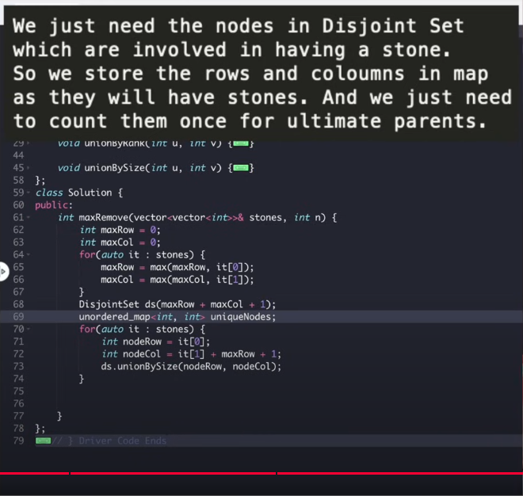
8. 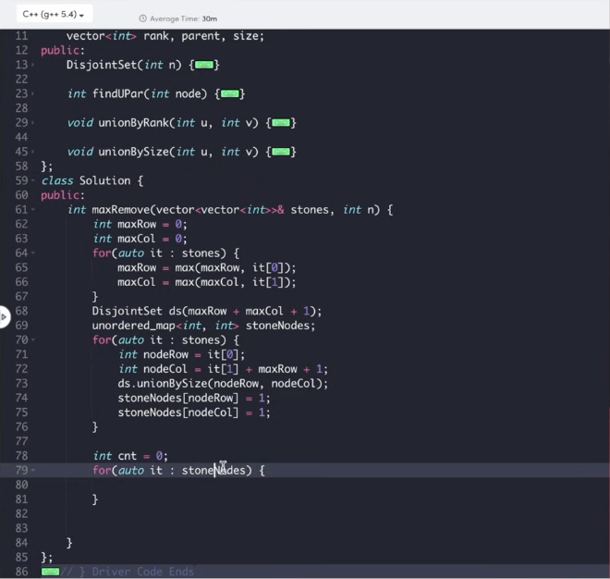
9. 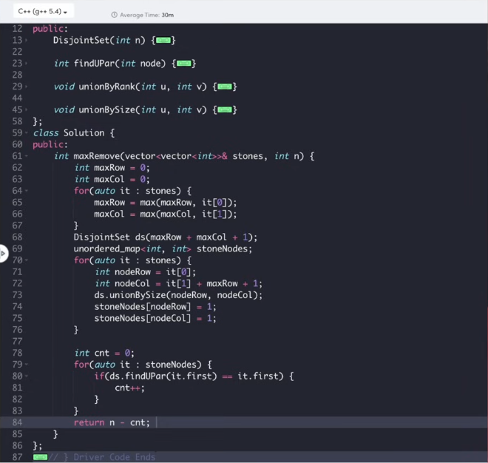

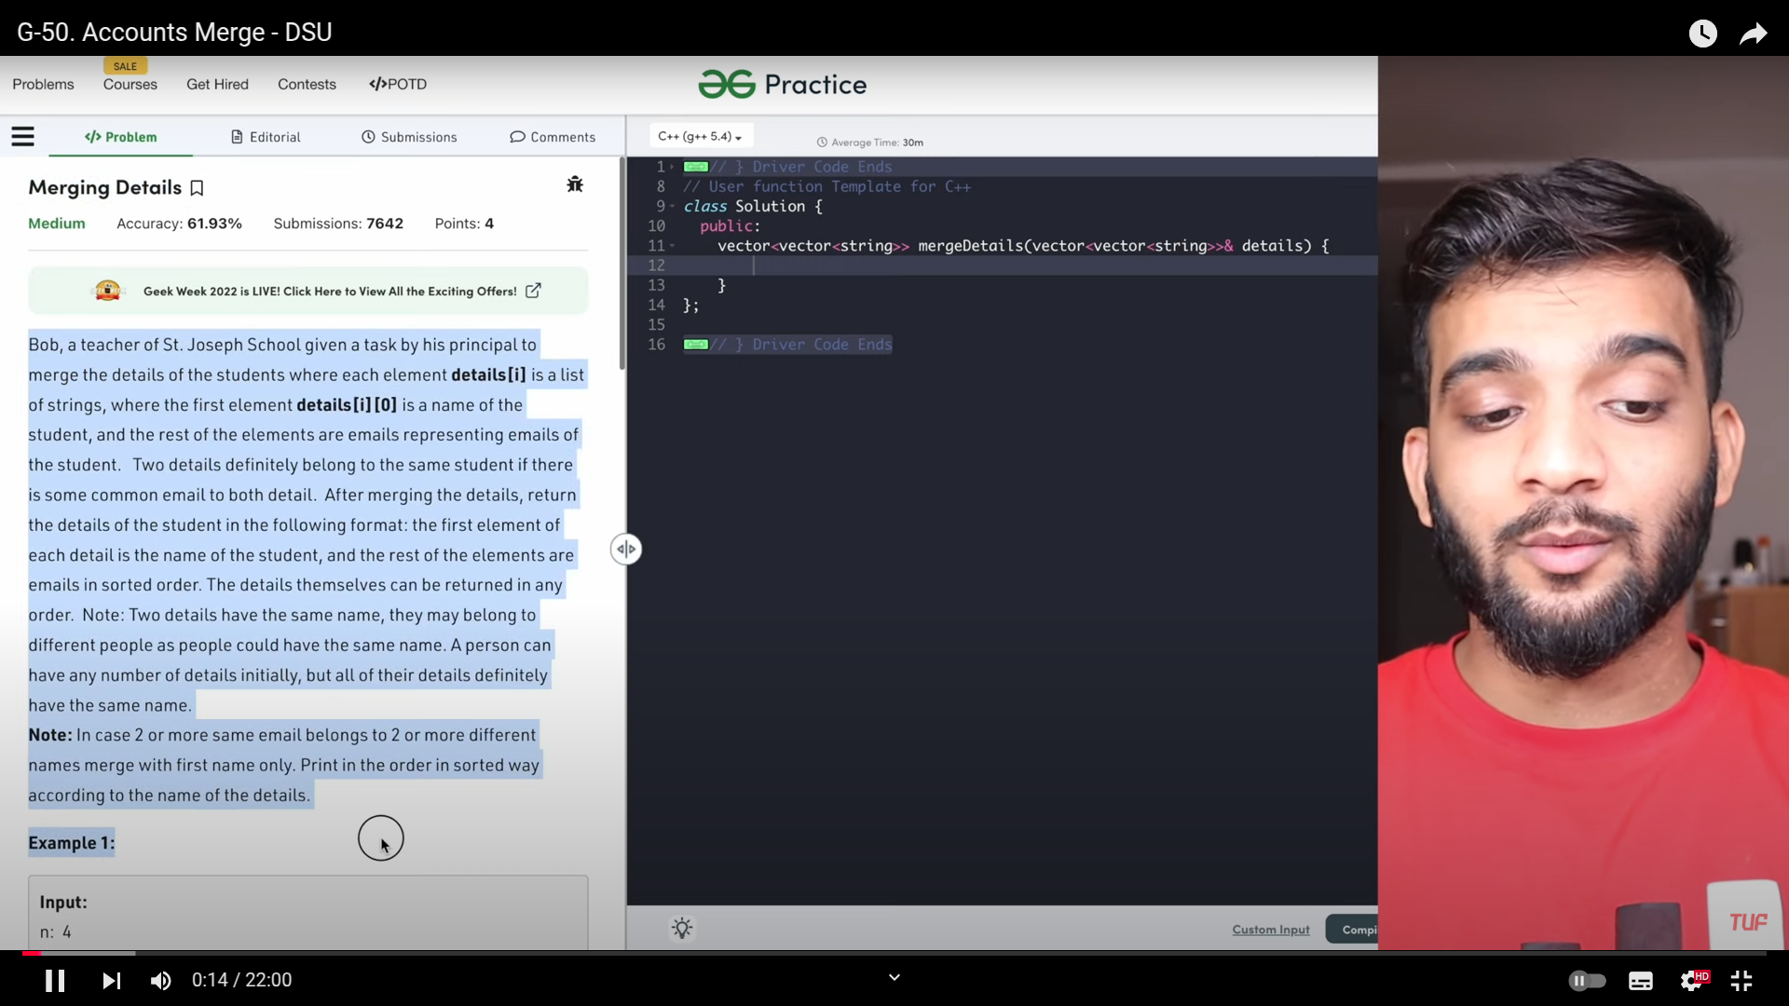

1. 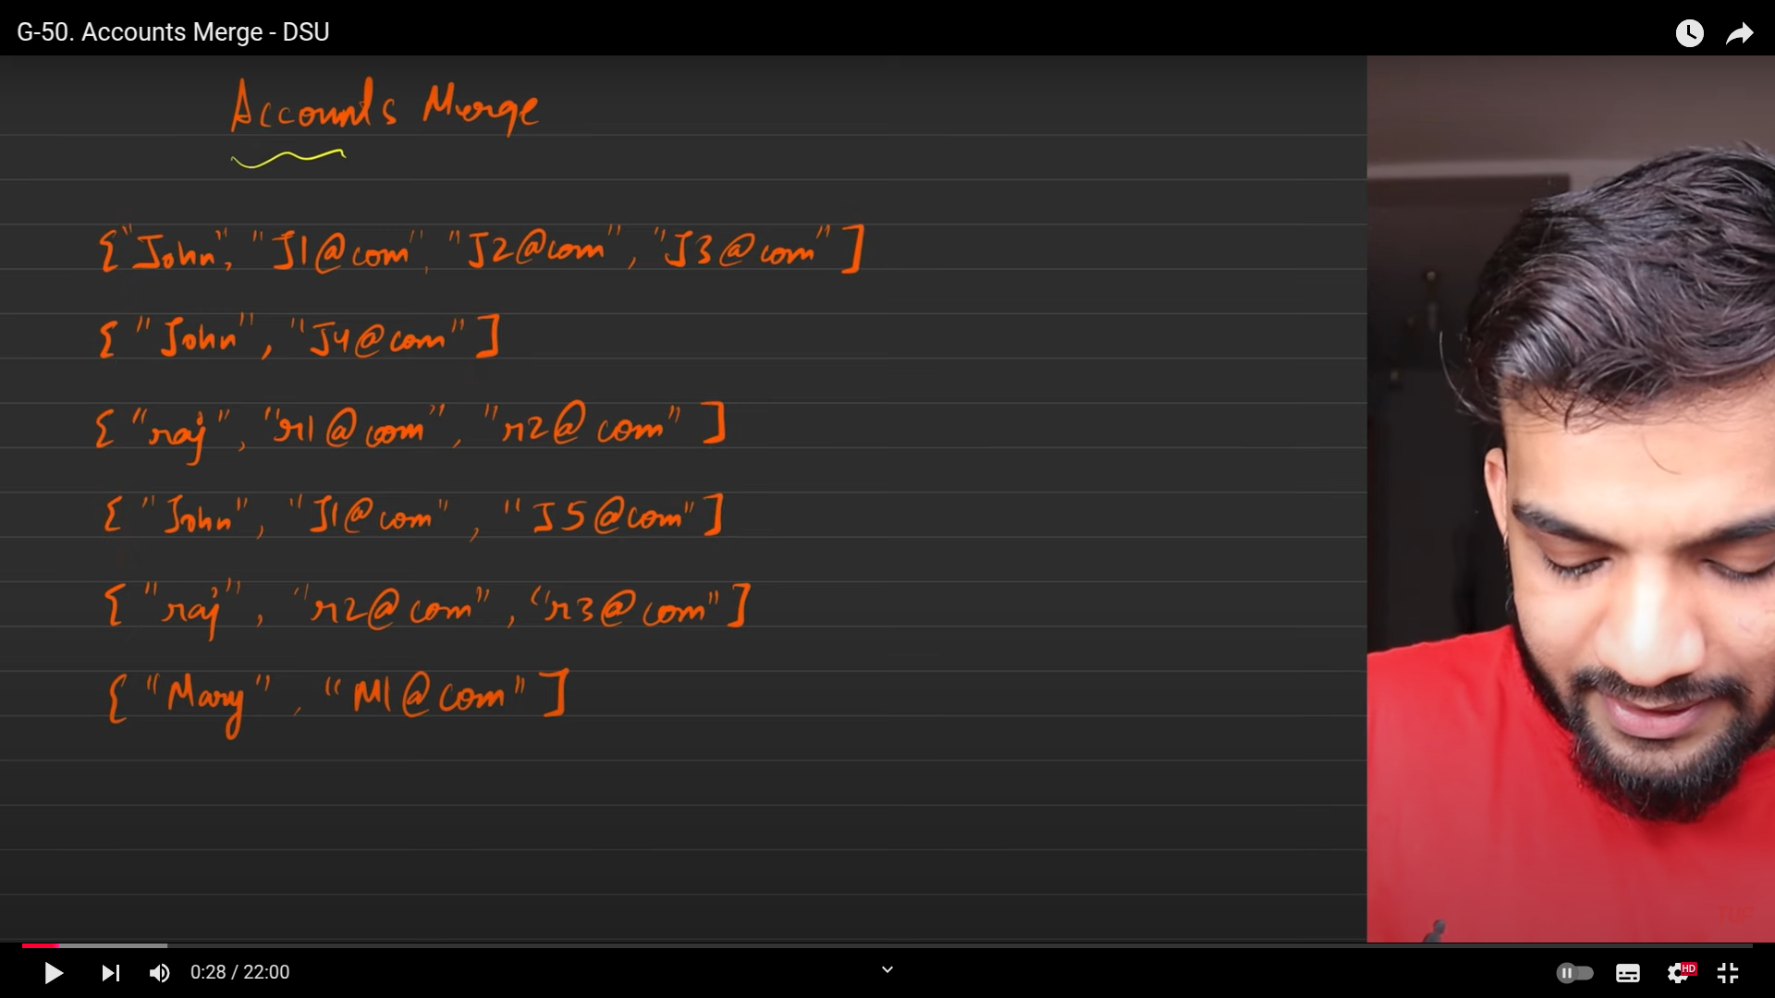
2. merger the similiar accounts.
3. 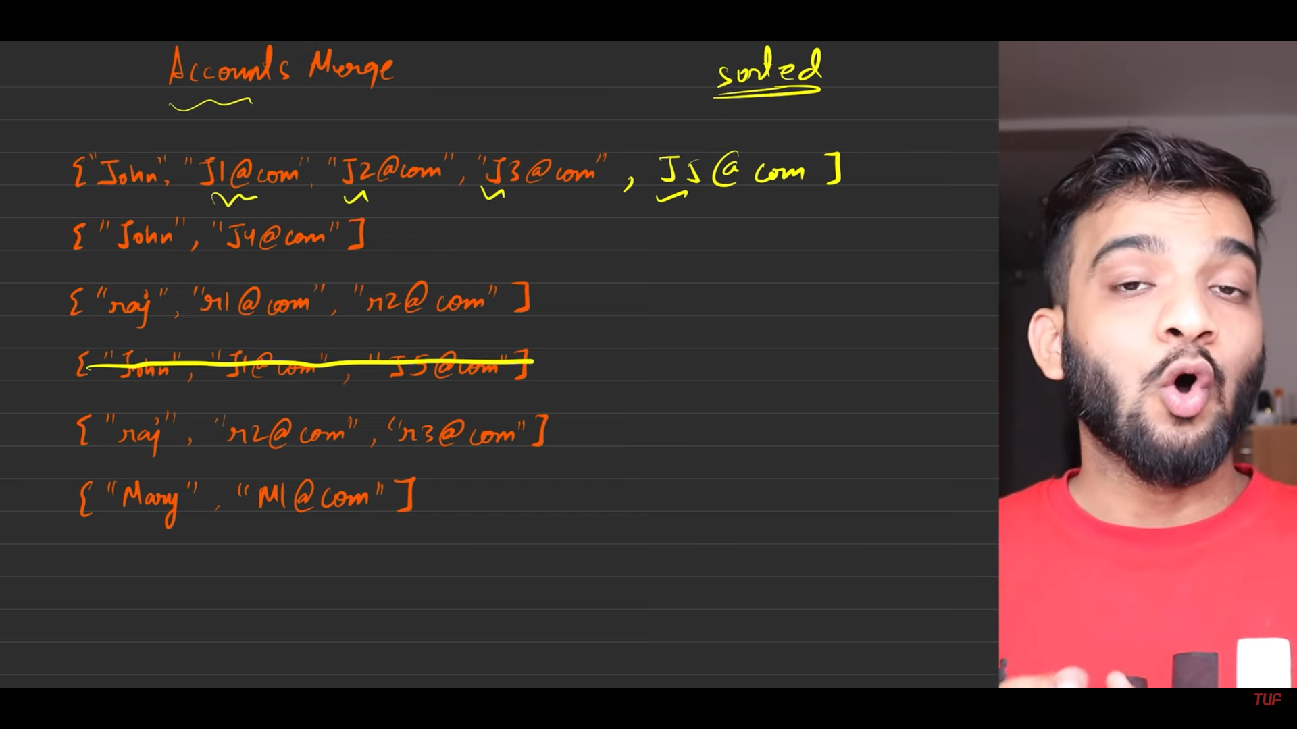
4. 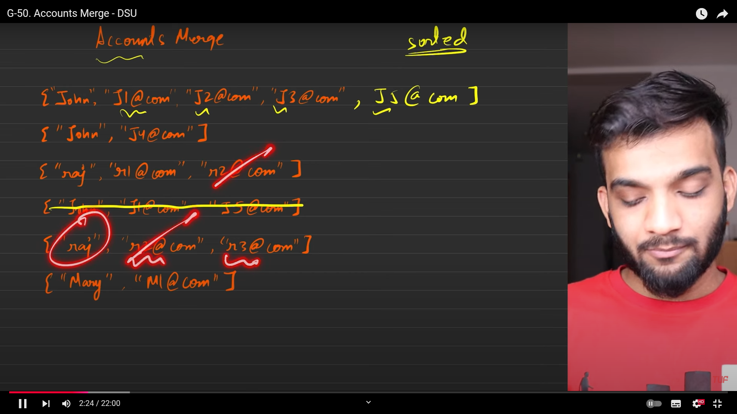
5. 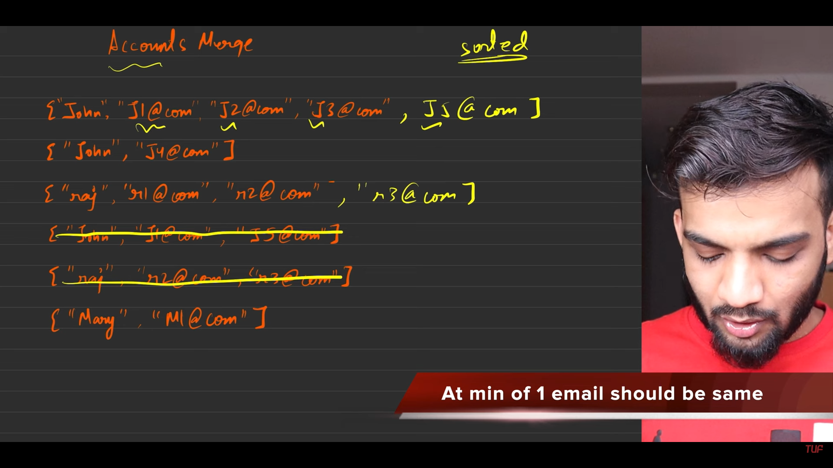
6. 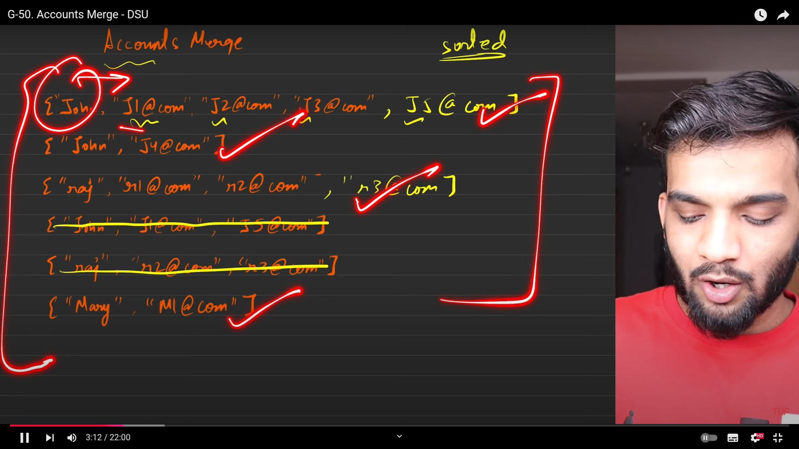
7. s